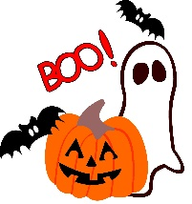
HALLOWEEN 2018

Friday Oct 19
7:00 PM S’mores by the campfire Community Firepit {behind the store}
8:00 PM Halloween Movie
Saturday Oct 20
DECORATE YOUR SITES CONTEST
11:00 AM HAY SCRAMBLE {at the Pavilion}
12-4 PM HALLOWEEN FESTIVAL {back of store}
PICK A PUMPKIN Decorate your Pumpkin and enter it for a chance to “win”
Climbing Wall and Obstacle course
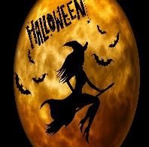
1-3 PM FACE PAINTING {next to store}, PONY RIDES {at playground}
This Photo by Unknown Author is licensed under CC BY
HALLOWEEN CRAFT
1:00 PM Tie Dye $10.00
2-4 PM HAY RIDES!! {IN FRONT OF PLAYGROUND}
5:00 PM COSTUME CONTEST ALL AGES: 1-5
6:00 PM COSTUME PARADE {while votes are being counted} meet at stage.
7:00 Pm TRICK OR TREATING around the campground
NO DRIVING VEHICLES AROUND DURING TRICK OR TREATING {IF YOU MUST LEAVE BEFORE 7 PM} STRICTLY ENFORCED
8:00 PM Halloween Movie
Sunday Oct 21
8:30 AM Contest Winners announced
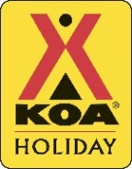
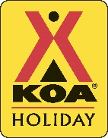
**WRIST BANDS MUST BE WORN AT ALL TIMES**
Follow us on Facebook activities will be posted and winners announced.
BOOK BEFORE YOU LEAVE FOR NEXT YEAR TO BE ASSURED YOUR FAVORITE SITE

