CHRISTMAS IN JULY

Friday July 20
7:00 PM Christmas S’mores by the campfire Community Firepit {behind the store}
8:00 PM Christmas Movie
Saturday July 21
DECORATE YOUR SITES CONTEST
12:00 PM Christmas scavenger hunt
1:00 PM Make melted snowman cookies
This Photo by Unknown Author is licensed under CC BY
2:00 PM Christmas Theme Children’s crafts
3:00 PM Tie Dye $10.00
5:00 PM Ugly Christmas shirt contest & Candy Bar Bingo
7:00 Pm Ice Cream Social make your own Christmas sundae
8:00 PM Christmas Movie
Sunday July 22
8:30 AM Contest Winners announced
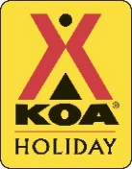
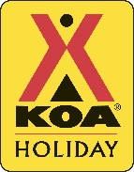
This Photo by Unknown Author is licensed under CC BY-SA

