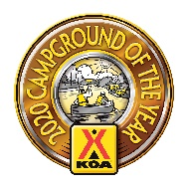
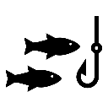
adventure

on the Youghiogheny River

Enjoy an

Rent a kayak, canoe, tracker or tube and let the fun

Our KOA rental team will drive you and the rental equipment 3 miles “up river” to Connellsville. Once at the river park, our team will assist you as you enter the water and start your float back to camp.
Typical float trips take as little as 1.5 hours in a canoe or kayak and up to 2 to 3 hours in a tube or tracker. Actual time spent on the river can depend on river conditions, fast or slow currents, and you enjoy!
Rental Fees
Canoe $40.00
Single Kayak $30.00
Double Kayak $40.00
Single Tube $20.00
Tube Tracker $25.00
Renters who are not camping pay an additional $10.00 fee per boat, tube or tracker.
All prices are subject to change without notice.
Shuttle Times
2 hour advanced reservations required
10 am 11 am Noon 1 pm 2 pm 3 pm
Driver’s license required to
secure rental.
License is kept in office until all equipment is returned in good condition.
Shuttle times may vary or be cancelled due to river conditions or other factors determined by management.
Shuttle riders must be old enough to ride without a car seat.

Registered Guests Shuttle Service Only
Your own equipment: $15.00 per person.
Advanced Reservations Required. Subject to availability.
Weekends excluded.
Fee includes each person’s equipment.
Liability waiver required.
For Reservations:
Call: 724-628-4880
Or, stop in the office.

