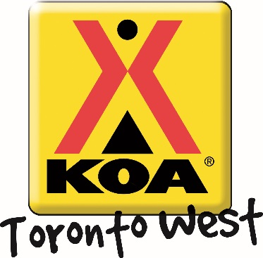
Halloween Weekend
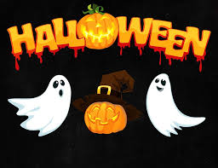
Welcome to our Halloween Weekend! The Toronto West KOA provides a variety of campground activities throughout the camping season geared to families and all-ages participation!
Friday August. 30th  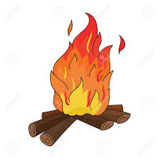 | Campfire! Dusk  Come warm up and join us for some delicious s’mores ($) around the campfire! We will be at the campfire pit outside the Kampstore – see you there!!
Saturday August. 31st  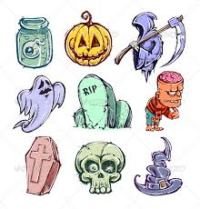 | Craft! (Sunday too!) 10:00 – 11:00 am  Meet us in the Rec Room for some spooky crafts!!  Ice Cream Social! (Saturday only!) 1:00 – 2:00 pm  We would love to see you at our Ice Cream Social! $2– with a portion of proceeds going to support United Way!  Activities! (Sunday too!) 2:00 – 3:00 pm  Come to the front of the Kampstore in your best Halloween costume and participate in lively activities! Bring your friends and family. Any age welcome! Those in costumes will receive a special treat! Jumping Castle 3:00pm – 6:00pm  Haunted Trail Walk (Saturday only!) Dusk  Join us at the Kampstore to sign a waiver for our haunted trail walk! Meet on group site #2 for the scares to start! Caution – We are not responsible for nightmares and soiled pants.  Movie Under the Stars! (Sunday too!) Dusk  Meet us outside the Kampstore to watch a movie under the stars. Don’t forget to bring snacks! The Kampstore has all your popcorn, candy and drink needs. If the weather is bad, the movie will take place in the Rec Room at 7:00pm!! Saturday night’s movie will be a kid friendly one – but prepare for Sunday night to scare your socks off!!
Sunday September 2nd | Pancake Breakfast! 8:30 – 10:00 am  Start your Sunday off with some pancakes outside the Kampstore! $3 for kids and $5 for adults: includes pancakes and coffee or juice. All proceeds are donated to United Way.  Anytime – All the time Activities: Try out your skills on our Scavenger Hunt and win a prize! Be sure to pick up your activity package at the Kampstore filled with colouring pages and activity sheets. Check out our lending library for great activities like Giant Jenga, movies and books. You can even rent bikes and try our mining station!

