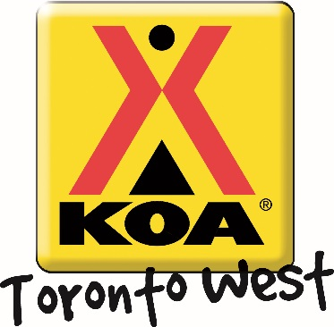
Mystical Magical Weekend!

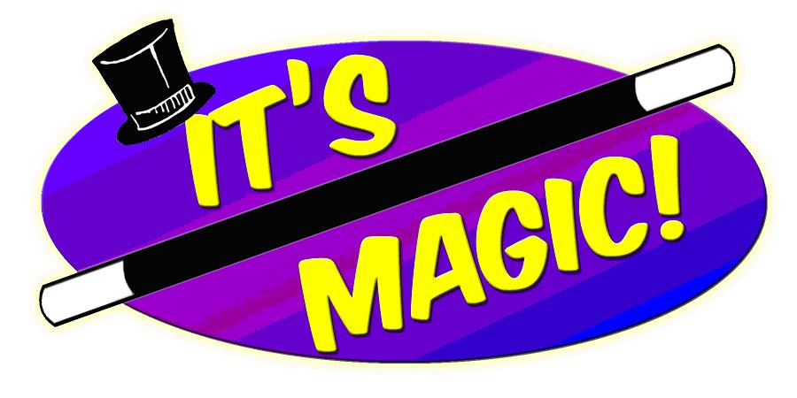
Welcome to our Father’s Day Weekend! The Toronto West KOA provides a variety of campground activities throughout the camping season geared to families and all-ages participation!
Friday July.12th 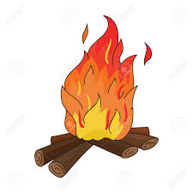 | Campfire! Dusk  Come warm up and join us for some delicious s’mores ($) around the campfire! We will be at the campfire pit outside the Kampstore – see you there!!
Saturday July.13th | Craft! 10:00 – 11:00 am  Come to the rec room and create a Magical Craft! Meet us in the Rec Room for the fun to begin  Ice Cream Social! 1:00 – 2:00 pm  We would love to see you at our Ice Cream Social! $2– with a portion of proceeds going to support United Way!  Activities! 2:00 – 3:00 pm  Come to the front of the Kampstore and participate in our magic show featuring Tyler Fergus! Bring your friends and family! Any age welcome!  Jumping Castle 3:00pm – 6:00pm  Movie Under the Stars! Dusk  Meet us outside the Kampstore to watch a movie under the stars. Don’t forget to bring snacks! The Kampstore has all your popcorn, candy and drink needs. If the weather is bad, the movie will take place in the Rec Room at 7:00pm!!
Sunday July.14th | Pancake Breakfast! 8:30 – 10:00 am  Start your Sunday off with some pancakes outside the Kampstore! $3 for kids and $5 for adults: includes pancakes and coffee or juice. All proceeds are donated to United Way.  Anytime – All the time Activities: Try out your skills on our Scavenger Hunt and win a prize! Be sure to pick up your activity package at the Kampstore filled with colouring pages and activity sheets. Check out our lending library for great activities like Giant Jenga, movies and books. You can even rent bikes and try our mining station!

