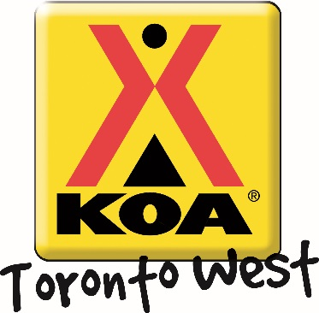
Thanksgiving Weekend
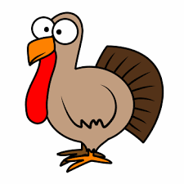
Welcome to our Thanksgiving Weekend! The Toronto West KOA provides a variety of campground activities throughout the camping season geared to families and all-ages participation!
Friday October. 11th 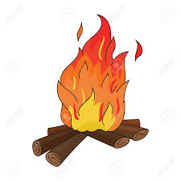 | Campfire! Dusk  Come warm up and join us for some delicious s’mores ($) around the campfire! We will be at the campfire pit outside the Kampstore – see you there!!
Saturday October. 12th  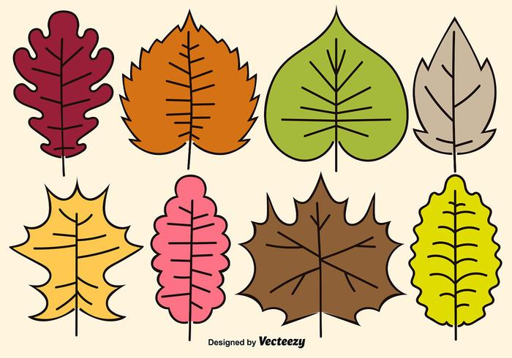 | Craft! (Sunday Too) 10:00 – 11:00 am  Meet us in the Rec Room for some fun crafts!! You’ll be Thankful you came!!!!  Ice Cream Social! (Sunday) 1:00 – 2:00 pm  We would love to see you at our Ice Cream Social! $2– with a portion of proceeds going to support United Way!  Activities! 2:00 – 3:00 pm  Come to the front of the Kampstore and participate in lively activities! Bring your friends and family. Any age welcome! Bounce in the Jumping Castle on Sunday 3:00pm – 6:00pm  Thanksgiving Dinner! (Saturday) 6:00pm  Join us this holiday weekend for our Thanksgiving Dinner! Enjoy turkey, ham and all the fixings! Adults $10 and Kids $5!!! RSVP in Kampstore!  Movie Under the Stars! Weather Permitting! Dusk  Meet us outside the Kampstore to watch a movie under the stars. Don’t forget to bring snacks! The Kampstore has all your popcorn, candy and drink needs.
Sunday October. 13th  Anytime – All the time Activities: Try out your skills on our Scavenger Hunt and win a prize! Be sure to pick up your activity package at the Kampstore filled with colouring pages and activity sheets. Check out our lending library for great activities like Giant Jenga, movies and books. You can even rent bikes and try our mining station! | Pancake Breakfast! 8:30 – 10:00 am  Start your Sunday off with some pancakes outside the Kampstore! $3 for kids and $5 for adults: includes pancakes and coffee or juice. All proceeds are donated to United Way.

