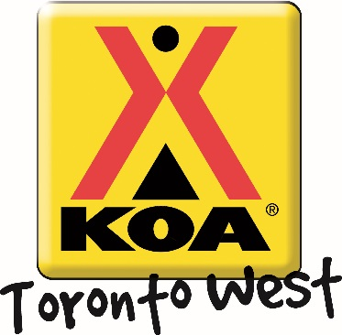
Carnival Weekend!!
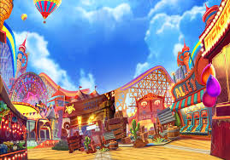

Welcome to our Carnival Weekend! The Toronto West KOA provides a variety of campground activities throughout the camping season geared to families and all-ages participation!
Friday August. 2nd  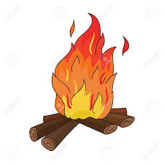 | Campfire! Dusk  Come warm up and join us for some delicious s’mores ($) around the campfire! We will be at the campfire pit outside the Kampstore – see you there!!
Saturday August. 3rd | Craft! (Sunday too!) 10:00 – 11:00 am  Don’t clown around!! Meet us in the Rec Room for some fun crafts!!  Ice Cream Social! (Saturday only!) 1:00 – 2:00 pm  We would love to see you at our Ice Cream Social! $2– with a portion of proceeds going to support United Way!  Activities! (Dunk Tank Sunday) 1:00 – 3:00 pm  Come to the front of the Kampstore and participate in lively carnival game activities Saturday! Sunday we’ll have a Dunk Tank! Bring your friends and family. Any age welcome!  Tyler Fergus - Magician! (Saturday) 2:00 pm  After you enjoy your ice cream, hang out and be amazed during our Magic Show!  Movie Under the Stars! Dusk  Meet us outside the Kampstore to watch a movie under the stars. Don’t forget to bring snacks! The Kampstore has all your popcorn, candy and drink needs. If the weather is bad, the movie will take place in the Rec Room at 7:00pm!!
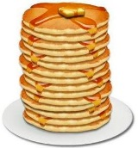  Sunday August 4th | Pancake Breakfast! 8:30 – 10:00 am  Start your Sunday off with some pancakes outside the Kampstore! $3 for kids and $5 for adults: includes pancakes and coffee or juice. All proceeds are donated to United Way.  Anytime – All the time Activities: Try out your skills on our Scavenger Hunt and win a prize! Be sure to pick up your activity package at the Kampstore filled with colouring pages and activity sheets. Check out our lending library for great activities like Giant Jenga, movies and books. You can even rent bikes and try our mining station!

