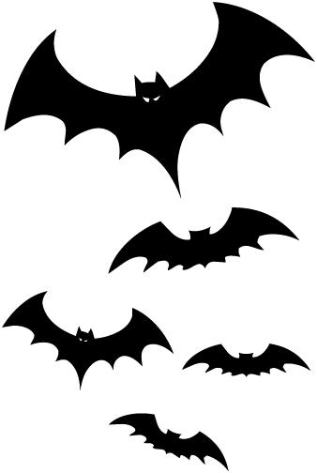
Grand River Valley KOA
Store Hours
Fri & Sat: 8a–7p
Sun-Th: 8a–6p
Pool Closed

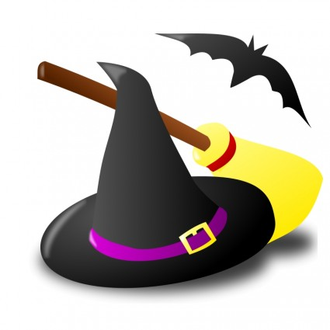
Halloween 2021
Friday 9/24 & 10/01
8pm: S’mores Roast @ Community Fire-Pit

Saturday 9/25 & 10/02
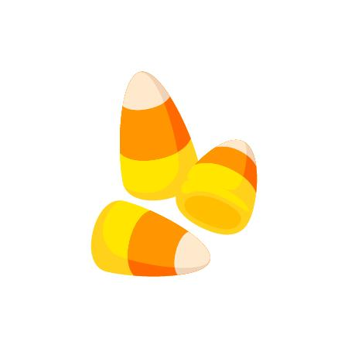
11am –2pm: Pumpkin Patch Fun! Join us for Biohazard Blast Obstacle Course, Sports Games, Pun’kins & a Creepy Craft! *Pumpkins for sale $$
4pm: Costume Contests (Playground Pavilion)
Trick or Treating!
Saturday
5-7pm

*Be sure children can be seen.
*Only approach participating sites.
*Please Be Present @ 4pm!! 1st, 2nd, & 3rd in each group.
Group 1: Pets
Group 2: Ages 0-5
Group 3: Ages 6-10
Group 4: Ages 11-16
Group 5: Ages 17+
Group 6: “Groups” (3 or more characters)
Group 7: Jack-o-lanterns contest. *Bring carved Pun'kin to Pavilion by 4pm!
5-7pm: Trick or Treating!!!
7-10pm: DJ Monster Mash! @ the CREEEEEPY Club House!
6-9pm: Site Decoration Judging (secret judge will be traveling sites, and announce winner Sunday morning @ store. Places 1, 2, & 3 awarded)
Upcoming 2022 Events will be posted online in the New Year!
Sunday 9/26 & 10/03
Thank You for Camping with us!
Check out @ 11 am: TRAVEL SAFELY!

Site Decoration Contest
For a chance to win great prizes!
Judging takes place between 6-9pm on Saturday.
Winners will be posted on Sunday morning in the store.
1st, 2^{nd,} 3rd Prizes awarded
Please make sure you check to see if you won!
