Games, Games, and More!
Store Hours
Fri - Sat: 8a – 8p
Sunday: 8a – 6p
Pool
9a-9p M-Sat
10a-9p Sunday
*Under 17 must have adult present in pool area

Friday 7/23
7pm Family Game Night – Come to the Main Club house and join in on a Family game of Camping Pictionary or your favorite board game. Who will be the winner??? All ages welcome!

Saturday 7/24
10am Kids Kraft – Kids of all ages. Meet at the big clubhouse for crafts. Small children will need to bring a “helper”

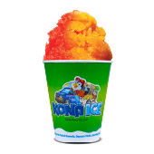
1pm Human Board Game – Meet at the field by the GAGA pit to play our human board game. Watch out, you might land on “Pie in the Face” or “Waterworks” All ages welcome!

3pm Kona Ice Truck $ - Come and enjoy some
refreshing shaved ice! YUMMY!

7pm Golf Cart Bingo $ - Meet behind the Big Club House. If you don’t have a golf cart, you are still invited, just bring a chair

Sunday 7/25
Check out @ 11am: TRAVEL SAFELY!
Thank You for Camping with us!
Thompson/Grand River Valley KOA

