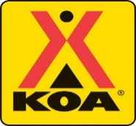
Santa Cruz/Monterey Bay
“Themed Weekend” Activity Calendar 2019

(May 24-27) Memorial Decoration Weekend
(May 31-June 2) Candyland Weekend
(June 7-9) Fiesta! Weekend
(June 14-16) Wild West (Father’s Day) Weekend
(June 21-23) Under the Sea Weekend
(June 28-30) Stars & Stripes Weekend
(July 5- 7) Pirates & Princess Weekend
(July 12-14) Christmas in July Weekend
(July 19-21) Hawaiian Luau Weekend
(July 26-28) Circus Carnival Weekend
(August 2-4) Jungle Weekend
(August 9-11) 50’s Weekend
(August 16-18) Wide World of Sports Weekend
(August 23-25) Wonderland Weekend
(August 30-September 2) Hooray for Hero’s (Labor Day) Weekend

