|  |  |  |  |
| --- | --- | --- | --- |
| **Friday**  May. 27 | **Saturday**  May. 28 | **Sunday**  May. 29 | **Monday**  May. 30 |
| **BIKE RENTALS open**  **9am-4pm**  Last bike rental begins at 4pm  ($15-$40/hour)  10am-Sunday @ 4pm:  Memorial Scavenger Hunt  12pm-1pm:  Palm Tree Climb  2pm-3pm:  Fun Train  6pm-7pm:  SMORES | **BIKE RENTALS open**  **9am-4pm**  Last bike rental begins at 4pm  ($15-$40/hour)  10am-11am:  CRAFT: Patriotic Glasses & Tattoos  12pm-1pm:  Tie Dye $  2pm-3pm:  Fun Train + Bike Parade  3pm-4pm:  Palm Tree Climb    6pm-7:30  Candy Bar BINGO $$$ | **BIKE RENTALS open**  **9am-4pm**  Last bike rental begins at 4pm  ($15-$40/hour)  10am-11am  CRAFT: Patriotic Ornament  12pm-1pm:  Ceramics $  2pm-3pm:  Fun Train  3pm-4pm:  Water Melon Eating Contest    5pm-6pm: Cotton Candy $ | **BIKE RENTALS open**  **9am-4pm**  Last bike rental begins at 4pm  ($15-$40/hour)  10am-11am:  Bubbles @ Sand Shack  12pm-1pm:  Palm Tree Climb  2pm-3pm:  Fun Train |

**Share your favorite camping memories**

**with us!**

**#SantaCruzKOA**

**BIKE RENTALS are *“wheel-y”*  FUN for all ages!**

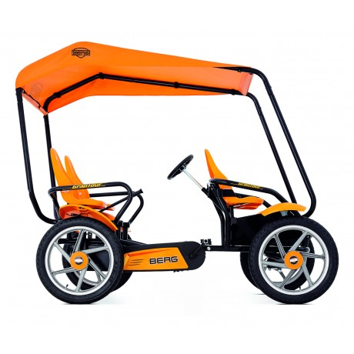

 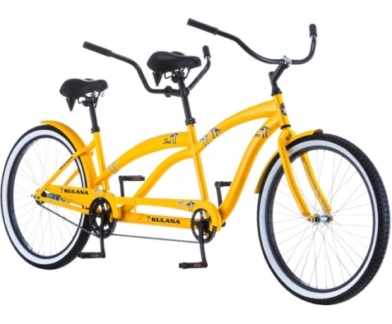

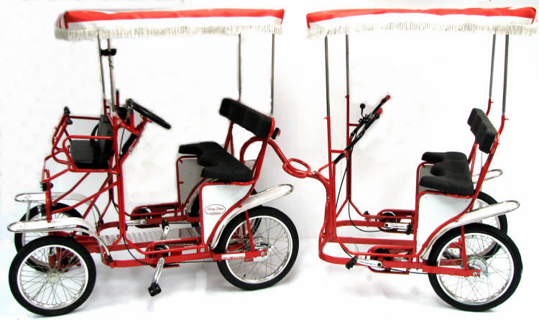



**ACTIVITY DETAILS**

**& LOCATIONS**

**Activities and events are subject to change, weather-permitting,**

**and while supplies last!**

**Fun Train:** Take a FREE ride on the KOA Express! Meet at the train depot in the center of the campground.

**Scavenger Hunt:**

Pick up your hunt list from staff in the Sand Shack! Find all of the answers around the campground, and you’ll earn a special treat!

**Palm Tree Climb:** Join us for a rock climbing adventure on our Palm Trees at the Beach Zone! It’s FREE! Will *you* make it all the way to the top?!

**Craft:** Meet at the sand shack to make your own patriotic art!

**Candy Bar Bingo:** Buy a candy bar in our store and come join us for bingo. Winners get a candy bar of their choice!

**DIPPIN DOTS available @ Sand Shack during bike rental hours ($6)**

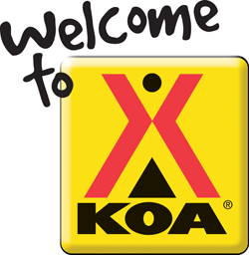

ACTIVITIES SCHEDULE

**May 27th – 30th**