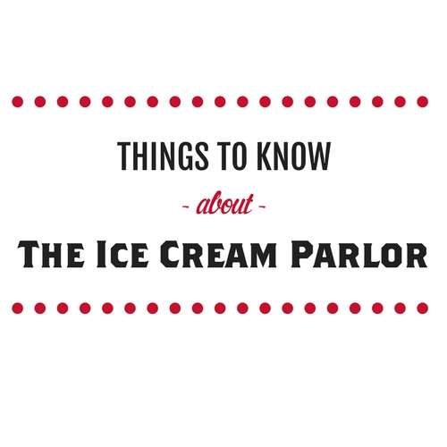

You can rent out Volleyballs, Shuffleboard equipment, horseshoes and basketballs from the Ice Cream Parlor window!

**Fried Foods**

Each serving **$4.00**

Dipping Sauces **$ .50**

French Fries, Curly Fries, Waffle Fries, Chicken Tenders, Chicken Fries, Jalapeno Poppers, Onion Rings, Mozzarella Sticks, Cheese Curds, Mini Tacos, Mini Corn Dogs

***Sauces:*** *Ketchup, Ranch, Mustard, Honey Mustard, BBQ, Cheese, Hot Sauce, Salsa, Sour Cream, Marinara*

**Nachos**

With cheese or Beef **$3.50**

Extra Cheese or Beef **$1.00**

*Jalapenos available upon request*

**Salads**

Tossed Salads **$5.00**

*\*add fried chicken for an additional $2.00\**

***Dressings:*** *Ranch, Italian, French, Raspberry Vinaigrette*

**Ice Cream**

Kiddie Cone (one scoop) **$2.00**

Single Cone (two scoops) **$2.75**

Double Cone (three scoops) **$3.50**

Monster Cone (four scoops) **$4.25**

*Waffle cone an additional $.50*

*Additional toppings $.50 per topping*

**Ice Cream Sundaes**

Small Sundae (one scoop) **$3.50**

KOA Super Sundae (three scoops) **$4.50**

***Toppings:*** *Hot Fudge, Hot Caramel, Whipped Cream, Cherries, Chopped Peanuts, M&M’s, Oreo, Reese’s, Chocolate Syrup*

**Smoothies and Shakes**

Shakes/Malts **$3.49**

Smoothies **$3.49**

Frappes **$3.49**

Frozen Lemonade **$3.49** *\*ask us about our flavor options\**

Menu