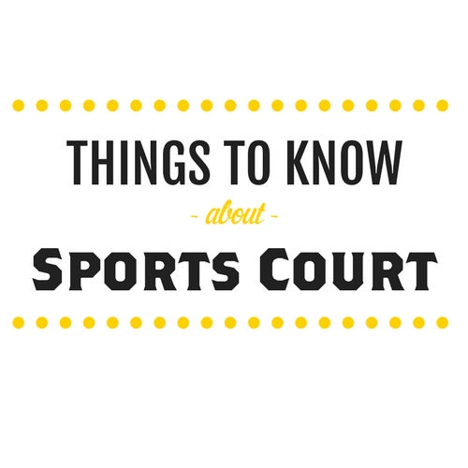

Sports Equipment

All sports equipment rentals are free.

**We have:** volleyballs, basketballs, hockey sticks, hockey balls, tennis racquets, tennis balls, dodge balls, Frisbees and horseshoes *(we do not rent out roller skates).*

There are basketball courts, a volleyball court, tennis courts and a roller hockey rink back at sports court. We also have our newest edition:

**GAGA BALL**.

Water Wars

Water balloons can be purchased inside of the Sports Court.

10 Balloons ………………..$1.00

Recreation Department

Most of the recreation department’s activities do take place back at the Sports Court. Stay tuned closer to your arrival date for an actual updated list of activities.

Golf Cart Rentals

Double Seat 4 Hours ………. $35.00

Double Seat 7 Hours ..……….$52.00

Double Seat = 4 Adults Maximum

Max. Weight capacity is 850lbs.

**All Carts must remain on KOA Roadways. They are not allowed on any trail.**

You must be 18 years of age or older (provide a valid Driver’s License to rent and drive golf carts.

**Must have a wrist band to drive.**

Must reserve in person, reservations only allowed up to 2 days in advance.

We only accept credit or debit payments for golf cart rentals.

**VIOLATION OF ANY RULE WILL RESORT IN LOSS OF THE CART WITH NO REFUND. Any damage will be charged to the responsible camper.**

What is the Sports Court?

Located in the back of the campground, the Sports Court is the area for kids of all ages. Free sports equipment, water wars, golf cart rentals and the Rec department, the Sports Court has it all!