|  |  |
| --- | --- |
| |  | | --- | |  | |

|  |  |
| --- | --- |
| |  | | --- | | **Mackinaw City/ Mackinac Island KOA** | |

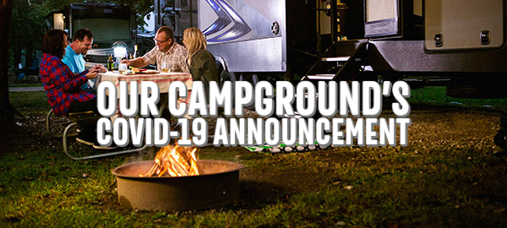

|  |  |  |  |  |
| --- | --- | --- | --- | --- |
| |  | | --- | |  | |  | | |  | | --- | | **Park Opens May29th**  After reviewing numerous state, county, and local government recommendations and regulations as well as the CDC and WHO, the Mackinaw City/Mackinac Island KOA has made the following changes through June 14, 2020 (subject to change) in an effort to stay open and offer a place for you stay:   * Fully Self-Contained RV's & Campers only (All Sites are full hookups) * Bath Houses are closed * All Accommodations are closed * Tent Sites are closed * Laundry room is closed * Dog Parks is open...1 dog & owner @ a time * Propane Filling Station is open * Ice & Firewood Delivery Upon Request * Limited Store Items Available for delivery   We're encouraging social distancing and no outside visitors to the park during your stay. | |

|  |  |  |  |
| --- | --- | --- | --- |
| |  |  |  | | --- | --- | --- | | |  |  | | --- | --- | | |  | | --- | |  | | | |

|  |  |  |  |
| --- | --- | --- | --- |
| |  | | --- | |  | | |  | | --- | | **Curbside Check-In /**  **After-Hours Registration Only**  **5/15 to 6/15 (Subject to Change)**  5-10 minutes ahead of your arrival, give us a call at 231-436-5643 to let us know you're arriving soon. If you forget to call ahead, call when you arrive, and we'll gladly assist you to your site between 1pm - 7pm. If we're not available upon arrival, we'll have a map highlighted with your name on it to direct you to your site in the night registration box. | |

|  |  |  |  |
| --- | --- | --- | --- |
| |  |  |  | | --- | --- | --- | | |  |  | | --- | --- | | |  | | --- | |  | | | |

|  |  |  |  |  |
| --- | --- | --- | --- | --- |
| |  | | --- | |  | |  | | |  | | --- | | **Postpone Instead of Cancel**  Like you, we are experiencing the impact COVID-19 is having on the world and understand that may mean you need to change your travel plans. Let us first encourage you to change your date if at all possible. As a small, family owned campground, we would love to keep your business and have the opportunity to serve you later this season. We are happy to make date adjustments at no charge. If that is not possible, know that we are here still to support you.   .  Our goal has always been to provide you with the best and most memorable camping experiences, so we hope we can continue enjoying the park now and well into the future.  With Sincerest Regards,  Doug and Kathleen Gregory  Mackinaw City/ Mackinac Island KOA  231-436-5643  mackinawcitykoa@gmail.com  Sheplers Ferry information- normal schedule  <https://www.sheplersferry.com/3-13-20-a-message-from-the-shepler-family-regarding-covid-19/>  Mackinac State Parks information:  <https://www.mackinacparks.com/>  <https://www.mackinacparks.com/wp-content/uploads/2020/05/2020-Opening-Dates-Delayed-May-1.pdf> | |