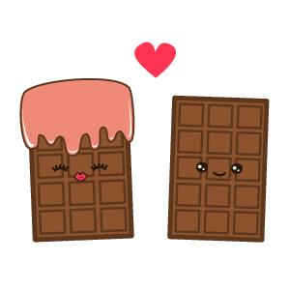
Louisville South KOA 2019
Store Hours
Fri & Sat: 8a – 8p
Sun-Th: 8a – 7p
Pool Hours
9a-9p M-Sat
10a-9p Sunday
*Under 17 must have adult present in pool area.

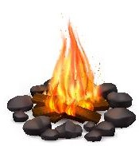
Chocolate Lovers!
All Activities @ Pavilion - unless specified
& weather permitting

Friday 7/19
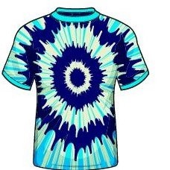
7pm: S’mores Roast @ Community Fire-Pit
Saturday 7/20
10am: Candy Bar Bingo – admission 1 candy bar.
Noon: Tie Dye – shirts sold in the store ($10) or $5 if you bring your own
2pm: Chocolate Games, bring a partner.
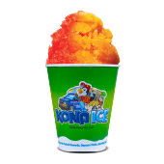
3pm: Chocolate slip n slide!
A special Thank You to the Shepherds-ville Fire Department!
Donations can be made toward the Crusade for Children program, which they support.
4pm -ish: KONA ICE Truck! Yummy!
9:30pm: Movie under the stars –
Willy Wonka & the chocolate Factory!
Rated PG

Sunday 7/21
Check out @ 11am: TRAVEL SAFELY!
Thank You for Camping with us!
Rate us a 5 & 10 stars on your survey and be entered to win a free night!
Upcoming Events
Hot Rods Weekend: 8/2-3
@LouisvillesouthKOA
Science Fun Weekend: 8/9-10
Value Card Member Weekend: 9/13-14

