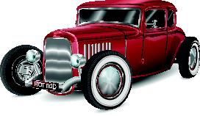
Louisville South KOA 2019
Hot Rod Weekend!
All Activities @ Pavilion - unless specified
& weather permitting
Store Hours
Fri & Sat: 8a – 8p
Sun-Th: 8a – 7p
Pool Hours
9a-9p M-Sat
10a-9p Sunday
*Under 17 must have adult present in pool area.

Friday 8/2
7pm: S’mores Roast @ Community Fire-Pit

Saturday 8/3
10am: Design your cars paint job!
Noon: Sweet Tooth Bingo!
Raffle:
Even Williams gift basket!
-benefiting Care Camps Charity
Purchase tickets at the Front Desk
*Must be 21+
Winner announced at the Pavilion (don’t need to be present to win)
SAT: 3:30PM
1 for $5
5 for $10
2pm: Tie Dye – shirts sold in the store ($10) or $5 if you bring your own
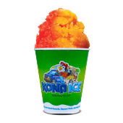
3:30pm: Raffle Drawing Announced!
4pm -ish: KONA ICE Truck! Yummy!
4pm: TIME TO DISPLAY YOUR HOT RODS!
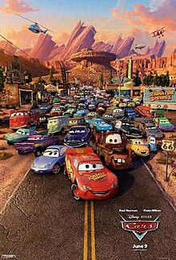
Showing/Judging 5-7pm Winner announced at 7:30pm!
1st, 2nd & 3rd place prizes awarded!
9:30pm: Movie under the stars –Cars Rated G

Sunday 8/4
Check out @ 11am: TRAVEL SAFELY!
Thank You for Camping with us!
Rate us a 5 & 10 stars on your survey and be entered to win a free night!
Upcoming Events
Science Fun Weekend: 8/9-10
Labor Day Weekend: 8/30-9/1
@LouisvillesouthKOA
Halloween Weekends: 10/18-19 & 25-26

