$$ ALL PROCEEDS, All Weekend, BENEFIT Kids Care Camp Charity!! $$
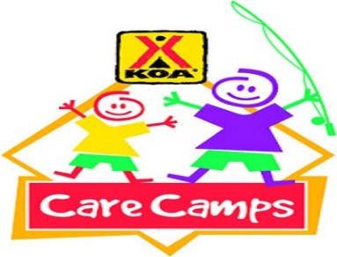
Care Camp Wknd!
Store Hours
Fri & Sat: 8a–7p
Sun-Th: 8a–6p
Pool Hours
9a-9p M-Sat
10a-9p Sunday
*Under 17 must have adult present in pool area.

All Activities @ Pavilion - unless specified
& weather permitting

Friday 5/8
7pm: S’mores Roast @ Community Fire-Pit

Saturday 5/9
Silent Auction
&
Raffle
Tickets & Bidding at the Front Desk
Winner announced at the Pavilion (don’t need to be present to win)
Saturday
4:30pm
10:30am: Make mom a card and a small gift
Noon: Big Deal Bingo! 3 rounds; $3/card, $5/card, & $10/card
2pm: Tie Dye – shirts sold in the store ($10) or $5 if you bring your own.
4:pm -ish: KONA ICE Truck! Yummy!
4:30pm Silent Auction/Raffle Winners Announced!

9pm: Movie Under the Stars – The Princess Bride
Rated PG

Sunday 5/10
Check out @ 11 am: TRAVEL SAFELY!
Thank You for Camping with us!
Rate us a 5 & 10 stars on your survey and be entered to win a free night!
Upcoming Events
Father’s Day weekend: 6/19-20
Dino Weekend: 7/10-11
@LouisvillesouthKOA

