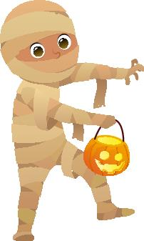
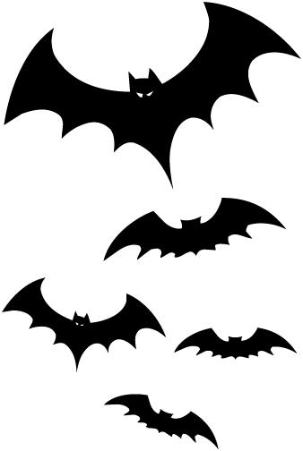
Halloween 2019!
Store Hours
Fri & Sat: 8a–7p
Sun-Th: 8a–6p
Pool Closed

All Activities @ Pavilion - unless specified
& weather permitting
Friday 10/18 & 25
8pm: Movie under the Stars – GREMLINS Rated PG-13

Saturday 10/19 & 26
10am – 2pm: Obstacle Course Challenge!
Noon: ”Make A Mummy Obstacle Race!” Bring a partner that doesn’t get dizzy!
2pm: Bobbing 4 Apples & Creepy Crafts!
4pm: 4pm: Costume Contests & Jack-o-lantern Judging!
*Please Be Present @ 4pm!! 1st, 2nd, & 3rd in each group.
Road Closure for Trick Or Treating!
All interior campground roads will be closed to street vehicles.
Saturday
5-6:30pm
*Be sure children can be seen.
*Only approach participating sites.
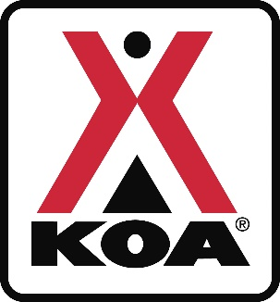
Group 1: Pets
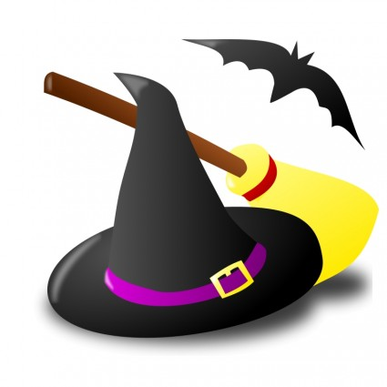
Group 2: Ages 0-5
Group 3: Ages 6-10
Group 4: Ages 11-16
Group 5: Ages 17+
Group 6: “Groups” (3 or more characters)
Group 7: Jack-o-lanterns. Bring carved Pun'kin to Pavilion by 4pm!
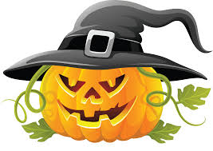
**Pumpkins for sale @ store.
5-6:30pm: Trick or Treating!!!
7-9pm: Monster Bash! Featuring:
DJ EZ P (19th) & DJ Kelz (26th)

Sunday 10/20 & 27
Thank You for Camping with us! Check out @ 11 am: TRAVEL SAFELY!
@LouisvillesouthKOA
Upcoming 2020 Events will be posted online in the New Year!

Site Decoration Contest
For a chance to win great prizes!
Judging takes place between 6-9pm on Saturday.
Winners will be posted on Sunday morning in the store.
1st, 2^{nd,} 3rd Prizes awarded
Please make sure you check to see if you won!
