Louisville South KOA 2019

Store Hours

Fri & Sat: 8a – 8p

Sun-Th: 8a – 7p

Pool Hours

9a-9p M-Sat

10a-9p Sunday

*Under 17 must have adult present in pool area.

Fun & Games!

All Activities @ Pavilion - *unless specified*

& weather permitting

**Friday 7/26**

**7pm:** S’mores Roast @ Community Fire-Pit

**Saturday 7/27**

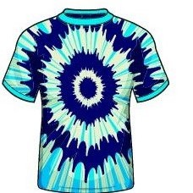**10am:** Tie Dye – shirts sold in the store ($10) or $5 if you bring your own

**Noon:** Minute to Win It Games!

**Win 2 Bundles of Firewood!**

Purchase tickets at the Front Desk

**Benefits Care Camps Charity $$**

Winner announced at the Pavilion (No need to be present to win.)

**SAT: 3:30PM**

1 for $2

3 for $5

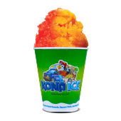**2pm**: FOAM PARTY!!!

**3:30pm:** Raffle Drawing Announced!

**4pm -ish**: KONA ICE Truck! Yummy!

**9:30pm:** Movie under the stars – Alice in Wonderland Rated PG



**Sunday 7/28**

Check out @ 11am: TRAVEL SAFELY! ☺

Thank You for Camping with us!

Rate us a 5 & 10 stars on your survey and be entered to win a free night!



Upcoming Events

**Science Fun Weekend:**  8/9-10

@LouisvillesouthKOA

**Kindness Rocks Weekend: 8**/16-17

**Labor Day:** 8/30, 31-9/1