Louisville South KOA 2020
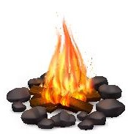
Beach Party!
Store Hours
Mon - Sat: 8a – 8p
Sunday: 8a – 7p
Pool Hours
9a-9p M-Sat
10a-9p Sunday
*Under 17 must have adult present in pool area.

All Activities @ Pavilion - unless specified
& weather permitting

Friday 5/29
7pm: S’mores Roast @ Community Fire-Pit
Saturday 5/30
10:30am: Make your own beach ball! & temporary tattoos
Noon: Tie Dye – shirts sold in the store ($10) or $5 if you bring your own
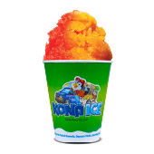
2pm: Limbo / Slip N Slide!
4pm -ish: KONA ICE Truck! Yummy!
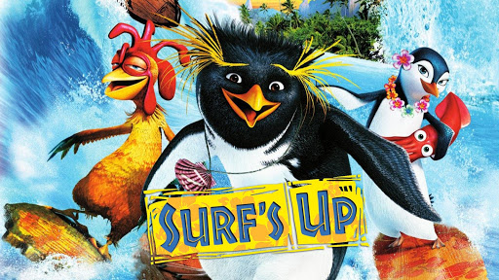
9:30pm: Movie under the stars – Surf’s Up! Rated PG

Sunday 5/31
Check out @ 11am: TRAVEL SAFELY!
Thank You for Camping with us!
Rate us a 5 & 10 stars on your survey and be entered to win a free night!
Upcoming Events
Story Book weekend: 6/12-13
@LouisvillesouthKOA
Dino Weekend: 7/10-11
Hot Rods Weekend: 8/7-8

