Louisville South KOA 2019
Store Hours
Fri & Sat: 8a – 8p
Sun-Th: 8a – 7p
Pool Hours
9a-9p M-Sat
10a-9p Sunday
*Under 17 must have adult present in pool area.

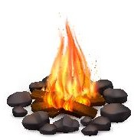
Fun & Games!
All Activities @ Pavilion - unless specified
& weather permitting

Friday 7/26
7pm: S’mores Roast @ Community Fire-Pit
Saturday 7/27
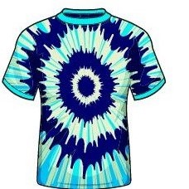
10am: Tie Dye – shirts sold in the store ($10) or $5 if you bring your own
Noon: Minute to Win It Games!
Win 2 Bundles of Firewood!
Purchase tickets at the Front Desk
Benefits Care Camps Charity $$
Winner announced at the Pavilion (No need to be present to win.)
SAT: 3:30PM
1 for $2
4 for $5

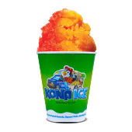
2pm: FOAM PARTY!!!
3:30pm: Raffle Drawing Announced!
4pm -ish: KONA ICE Truck! Yummy!
9:30pm: Movie under the stars – Alice in Wonderland Rated PG

Sunday 7/28
Check out @ 11am: TRAVEL SAFELY!
Thank You for Camping with us!
Rate us a 5 & 10 stars on your survey and be entered to win a free night!
Upcoming Events
Science Fun Weekend: 8/9-10
@LouisvillesouthKOA
Kindness Rocks Weekend: 8/16-17
Labor Day: 8/30, 31-9/1

