Memorial Holiday!
Store Hours
Mon - Sat: 8a – 8p
Sunday: 8a – 7p
Pool
9a-9p M-Sat
10a-9p Sunday
*Under 17 must have adult present in pool area.

All Activities @ Pavilion - unless specified
& weather permitting
Friday 5/22
7pm: S’mores Roast @ Community Fire-Pit
Saturday 5/23
10:30am: Sand Art & temporary tattoos!
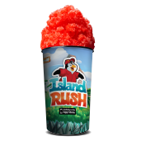
Noon: Sweet Tooth BINGO!
2pm: FOAM PARTY!! Meet @ pavilion
4pm -ish: KONA ICE Truck! Yummy!
50/50
Drawing for Care Camps
Purchase tickets at the Front Desk
Winner announced at the Pavilion (don’t need to be present to win)
Sat: 4:30pm
1 for $1
15 for $10
4:30pm: 50/50 Raffle Winner announced
9pm: Movie under the stars – The Wizard of OZ
Rated G
Sunday 5/24
10:30am: Patriotic Sun-Catchers
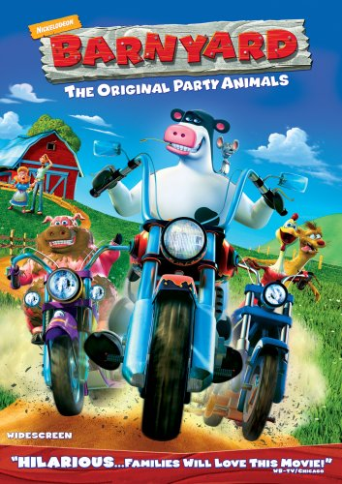
Noon: Tie Dye – shirts sold in the store ($10) or $5 if you bring your own.
2pm: Games @ the Activity Park! (Meet @ fire pit)
9pm: Movie under the stars – Barnyard Rated PG

Monday 5/25
Check out @ 11 am: TRAVEL SAFELY!
Thank You for Camping with us!
Rate us a 5 & 10 stars on your survey and be entered to win a free night!
Upcoming Events
Story Book weekend: 6/12-13
Dino Weekend: 7/10-11
@LouisvillesouthKOA

