Louisville South KOA 2019
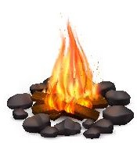
Summer Fun!
All Activities @ Pavilion - unless specified.
** weather permitting
Store Hours
Mon - Sat: 8a – 8p
Sunday: 8a – 7p
Pool Hours
9a-9p M-Sat
10a-9p Sunday
*Under 17 must have adult present in pool area.

Friday 6/7
7pm: S’mores Roast @ Community Fire-Pit

Saturday 6/8
10am: Squish Balls & Temporary Tattoos!
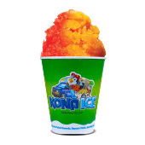
Noon: Tie Dye – shirts sold in the store ($10) or $5 if you bring your own
2pm: Foam Party!
Win a Marshmallow Blaster!
Purchase tickets at the Front Desk
Benefits Care Camps Charity $$
Winner announced at the Pavilion (No need to be present to win.)
SAT: 3:30PM
1 for $2
4 for $5

3:30pm: Raffle Drawing Announced!
4pm -ish: KONA ICE Truck! Yummy!
9:30pm: Movie under the stars – Alice in Wonderland Rated PG

Sunday 6/9
Check out @ 11am: TRAVEL SAFELY!
Thank You for Camping with us!
Rate us a 5 & 10 stars on your survey and be entered to win a free night!
Upcoming Events
Dino Weekend: 6/28-29
@LouisvillesouthKOA
Chocolate Lovers Weekend: 7/19-20
Hot Rods Weekend: 8/2-3

