Dear Campers,
Join us in our Western Gold Rush Palooza event September 3rd – September 5th

Gabby, the old prospector will be here, and
he knows how to find gold! So don’t be afraid
to ask him…
Don’t forget to dress like a prospector! (Cowboys or Pioneers) You’ll be able to show off your western outfits at one of our many
games from sack races, to pie eating contests, you are sure to have a blast in our wild, wild west!
Then, join us for our main event… GOLD RUSH!!
There will be gold to search for around the park, as well as panning for some in our very own West Canada Creek! Then, at the end of the day, once you finish prospecting, stop by to weigh your gold, and trade it for items in our general store!
We also invite each family design your very own covered wagon, as you will be able to enter it in our Covered Wagon Race, and Best Design Contest. You can use any type of wagon, just decorate!
We will also be giving a prize to the

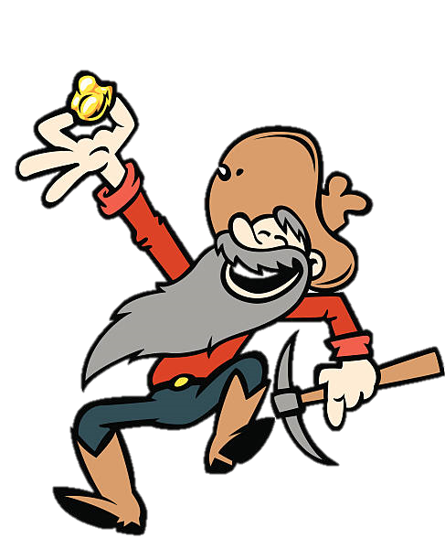
“BEST DRESSED FAMILY”
ACTIVITYS ALL WEEK LONG - LEADING UP TO OUR WEEKENDS MAIN EVENT!
BOOK YOUR RESERVATION SOON AS SITES FILL UP FAST!
We will see you soon!

