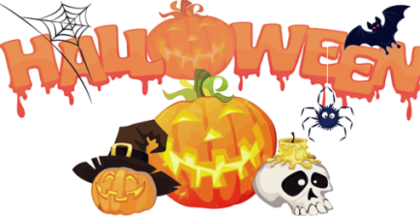

Happy Halloween
Food Truck
Friday-Saturday night Pizza open from 4:30p-6:30p
Saturday-Sunday morning Breakfast from 8am-10am

Friday 29th
6-7pm Wine, Cheese, Donut Social @ Pavilion
4-6pm KOA Train Rides Meet at the Train Depot by the store

Saturday 30th
10 am @rec Halloween Fun Run ($20 includes Halloween Shirt)
12-2pm KOA Train Meet at the Train Depot by the store
2-4pm Painted Halloween Pottery ($3 Small, $5 Big) and
Minute to Win It Games @ rec
4:30-5pm Trick or Treating (those who want to hand out candy are encouraged to sit outside with a bowl of candy)

Contests Held on Saturday
Site Decorating: Cabin, RV Sites and Tent Sites: 1st place 2 nights free, 2nd place 1 night free, 3rd place 25% off up to 2 nights
Pumpkin Carving: Set your pumpkins out at your site: Free Ice Cream
Judging will be done after dark. Results will be sent out through Zingle and posted at the chuck wagon on Sunday morning

Costume Contest: pet, kid, adult, group – stop by rec to get a pic taken between 12 and 3 and winner will be announced at social at 6:20: $25 Gift Card

6-8pm Haunted Train. Meet at the Train Depot by the store
6pm-8pm @ Community Fire Pit
Smores ($1) and Hot Chocolate ($1)
6:30-8pm DJ and Dancing

