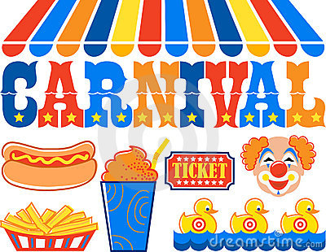

Weekend at Emmett KOA

6/21-6/24

Thursday

9:00am-DUSK $Jumping Pillow

Friday

9:00am-DUSK $Jumping Pillow

7:30-9:00 Rolling Video Games at the Pavilion

**(VIP wristband required)**

Saturday

9:00-DUSK $Jumping Pillow

10:00 Barrel Train Ride meet outside the store **(VIP wristband required)**

11:00-11:30 Parachute Games by playground

11:30-12:00 Gaga Ball meet at the Pit

2:00-3:00 Carnival Games at the Pavilion

**(VIP wristband required)**

4:00-5:00 $Bingo at the Pavilion ($1 per card)

7:00-? Wagon Ride Meet in front of the store

**(VIP wristband required)**

8:00 Magic show at the Pavilion (Roland James & His Amazing Birds of Paradise)

Sunday-

9:00-10:30 $ Breakfast at the Pavilion

ALL YOU CAN EAT $7 Adults/ $4 Children 10-under

9:00am-DUSK $Jumping Pillow

11:00-11:30 Scavenger Hunt meet at the Pavilion

6:00pm-? Barrel Train Ride meet outside the store

7:00-7:30pm $Ashby’s Ice Cream at the Pavilion



Flipper Snack Bar at the Pavilion:

Hunt’s Pizza, Wings & Ashby’s Ice Cream

Friday: 5pm-9pm

(last pizza & wing call 8:30)

Saturday: 1pm-9pm

(last pizza & wing call 8:30)

Sunday: 9am-10:30am (breakfast)

&

7:00-7:30pm Ice Cream only

**\*Saturday 6/23 at 10am reservations will open up until 6/23/19\***