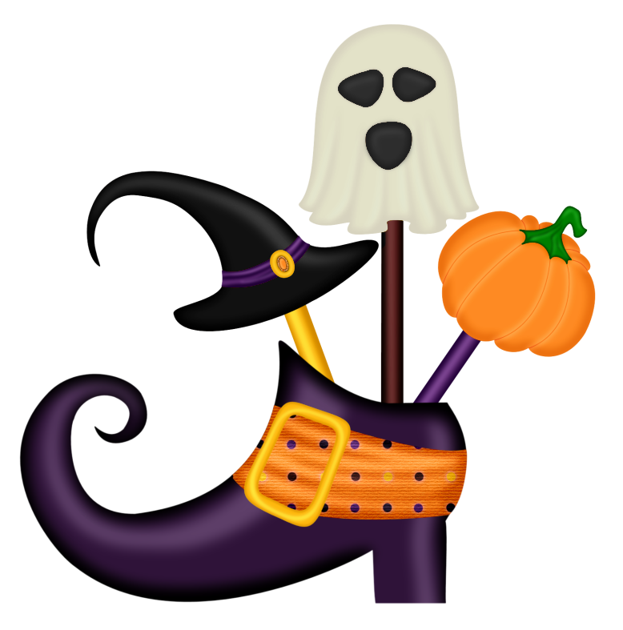
**TRYING SOMETHING NEW THIS WEEKEND WITH RESERVATIONS: Saturday Oct 7th at 8AM sites will open for reservations for Halloween III 2018 (Except 66-73, DS7 & DS8) & TWO (sites) per person maximum (October 5-7 2018) 2018)**
Halloween III
At Emmett KOA
10/6-10/8
Friday- 9:00am-DUSK $Jumping Pillow
5:00-9:00 Flipper Snack Bar at the Pavilion (last order 9:00pm)
8:30pm Halloween movie under the Stars/ $1 Popcorn

Saturday 9:00am-DUSK $Jumping Pillow
10:00-10:30 Barrel Train ride meet in front of the store (must have VIP wristband for entry)
11:00am-11:45am Halloween Magic Show at the Pavilion
12:00-12:45 Pumpkin Painting at the Pavilion $5 per pumpkin (last call 12:20 for pumpkins)
1:00-3:00 Flipper Snack Bar at the Pavilion
1:30-2:30 $1 Halloween Bingo at the Pavilion
3:30pm Costume Judging near playground for all ages (must have VIP wristband for entry)
Following Costume Contest for 1 hr Trick or Treating Site to Site
*NO WOOD OR ICE DELIVERIES AFTER 7:00 PM SATURDAY*
*NO BIKE RENTALS AFTER 6:30 PM SATURDAY*
*QUIET TIME AT 11PM- NO SPOT LIGHTS & GAMES OR RADIOS PLEASE
NO CARS ARE TO MOVE DURING TRICK OR TREATING!
5:00-7:00 Flipper Snack Bar at the Pavilion (last order 6:45)

7:00pm-10:00pm Ghost & Goblins Dance Party at the Pavilion
7:45pm-? Wagon Ride to Haunted Forest Meet in front of the Store (must have VIP wristband for entry) Weather Permitting
**Saturday October 2nd10AM sites will open for reservations for Halloween 2 2016 (September 30-October 2)

Sunday- 9:00am-10:30am $ Breakfast at the Pavilion
Adults $7/ Children 10-under $4
9:00am-12:00pm $Jumping Pillow
10:30am Prompt Announce Site
Decorating Winners at the Pavilion- Must be present to win!
Flipper Snack Bar
(At Pavilion)
Friday 5pm-9pm
(last pizza/wing order 9pm)
Saturday 1pm-3pm & 5pm-7pm
(last pizza/wings order 6:45pm)

