- ALL REGISTERED GAMPERS AND VISITORS MUST HAVE A WRISTBAND SHOWING REGISTRATION.
- Visitors are welcome for an additional $6 a person and their car will remain in visitors parking with a carpass.
- Check out is Noon; late check out is available for an additional $15 extending check out time to 5pm for all campsites excluding accommodations, if the site is available.
- NO OUTSIDE FIREWOOD.
- PETS ARE WELCOME IF THEY ARE CONTROLLED AND CLEANED UP AFTER.
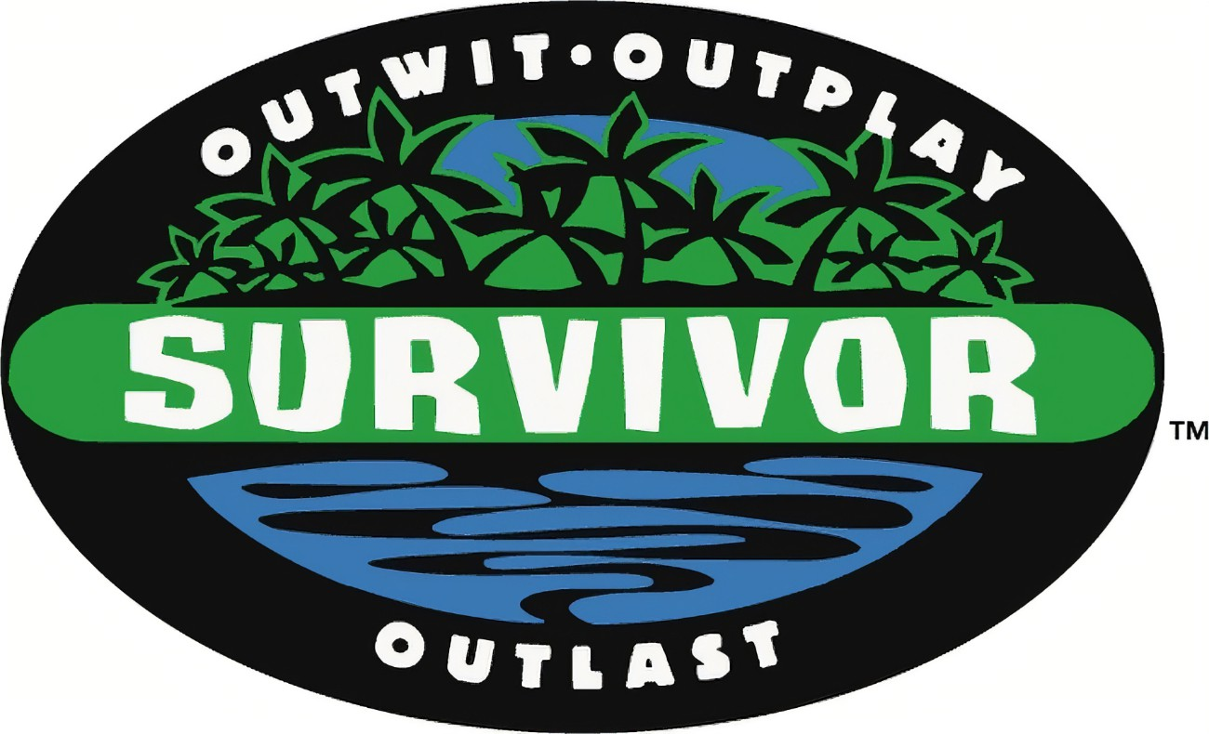
EMMETT KOA SURVIVOR
WEEKEND EVENTS
WIFI – Emmett KOA Guest – Password: happycamper

Store Hours 9am-9pm
Wood Deliveries, Jumping Pillow, Bike, Putt Putt 9am-8:45pm
Bathhouse Daily Cleaning 9am, 2pm and 7pm
Swimming and Catch and Release Fishing Dawn- Dusk
**Reserve your current campsite for this weekend in 2022 by Sunday at Noon. **

FRIDAY
10:30am Barrel Train meet behind the store
12pm-2pm Order Pizza, Wings and Ice Cream at the Store
5pm-9pm Pizza, Wings, Ice Cream at Snack Bar
9pm/dusk Movie under the stars near the Pavilion. $1 Popcorn
SATURDAY
10:30am Barrel Train meet behind the store
12pm-2pm Pizza, wings, ice cream at the Snack Bar
2:30pm Survivor activities near the pavilion
4pm-5pm Bingo $1 at the pavilion
5pm-9pm Pizza, wings, ice cream at the Snack Bar
7pm-10pm DJ at the pavilion
SUNDAY
12pm-2pm Pizza, wings, ice cream order in the Store

**Weather permitting; activities may be held under the pavilion due to rain.

