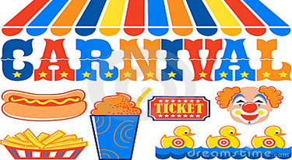
Weekend at Emmett KOA
6/26-6/28
Friday-
9:00am-9:00pm Jumping Pillow (Registered camper wristband required)
4:00pm-8:30pm Flipper Snack Bar at the Pavilion
9:00pm Movie under the stars

Saturday-
9:00am-9:00pm Jumping Pillow (Registered camper wristband required)
9:00am-10:00am Yoga on the Beach $7 (Bring a towel or blanket cash or Paypal)
10:00am? Barrel Train Ride meet in front of the store ( 6 feet social distancing, Registered camper wristband required, one ride per person)
1:00pm-8:30pm Flipper Snack Bar at the Pavilion
7:00-? Barrel Train Ride meet in front of the store ( 6 feet social distancing, Registered camper wristband required, one ride per person)
8:00-Magic Show at the Pavilion (DON’T MISS THE SHOW!!! Families please sit together 6 feet social distancing)

Sunday-
9:00-9:00pm Jumping Pillow (Registered camper wristband required)
7:00pm-? Barrel Train Ride meet in front of the store ( 6 feet social distancing, Registered camper wristband required, one ride per person)
8:00-8:30 $Ashby’s Ice Cream at the Pavilion ($4 single, $6 Double scoop)
Reservations for Carnival 2021 Weekend will begin at your convenience during your stay this weekend
For June 25-27 2021. Reserve your same site for next year and pay the deposit before you leave this weekend. No waiting in line please.
Thank you
Flipper Snack Bar
Featuring Hunt Brother’s Pizza & Wings & Ashby’s Ice Cream:
At the Pavilion
Friday: 5pm-8:30pm
Saturday:1pm-8:30pm
Last pizza/wing before 8:30pm

