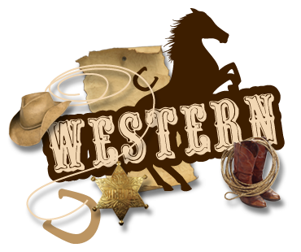
Weekend
At Emmett KOA
July 27-30

Thursday:
9:00-8:30pm $Jumping Pillow
4:15-4:45 Sandcastles at the Beach
Flipper Snack Bar

6:00-6:30 Gaga Ball meet at the Pit
7:00-7:30 Games near the Playground
7:30-8:00 Scavenger Hunt meet at the Pavilion

Friday: 9:00am-8:30pm $Jumping Pillow
10:30am Barrel Train ride meet outside the store
8:30pm Movie under the stars/ $1 popcorn/ Toy Story 3

Saturday: 9:00am-8:30pm $Jumping Pillow
2:00-2:30 Gold Rush!! Kids don’t miss this! (Near the Playground)
4:00-5:00 $Bingo at the Pavilion
6:30 Wagon Ride Meet Promptly at the Store
7:00-10:00 Hoe-Down & at the Pavilion

Sunday: 9:00-10:30 $ Breakfast at the Pavilion
Adults $7/ Children 10-under $4
9:00am-8:30pm $Jumping Pillow
7:00 Barrel Train ride meet outside the store
8:00-8:30 $Ashby’s Ice Cream at the Pavilion

*Hunt’s Pizza, Hunt’s Wings & Ashby’s
Ice Cream*
(AT THE PAVILION)
Thursday 4pm-9pm
Friday 4pm-9pm
Saturday 12pm-9pm
Sunday 9am-10:30am breakfast &
8pm-8:30pm ice cream only

