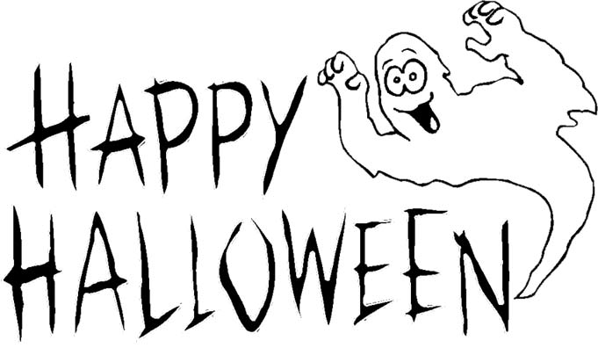
RESERVATIONS: Saturday Oct 20th at 8AM sites will open for reservations for Halloween 5 2019 TWO (sites) per person maximum and no holding places please (Oct 18-20 2019)**

Halloween 5 at Emmett KOA
10/19-10/21
Friday- 9:00am-DUSK $Jumping Pillow
5:00-9:00 Flipper Snack Bar at the Pavilion (last order 8:30pm last pizza & wing order)
8:00pm Halloween movie under the Stars/ $1 Popcorn

Saturday 9:00am-DUSK $Jumping Pillow
10:00-10:30 Barrel Train ride meet in front of the store (must have VIP wristband for entry)
11:00am-11:45am Halloween Magic Show at the Pavilion
12:00-12:45 Pumpkin Painting at the Pavilion $5 per pumpkin (last call 12:20 for pumpkins)
1:00-3:00 Flipper Snack Bar at the Pavilion
1:30-2:30 $1 Halloween Bingo at the Pavilion
3:30pm Costume Judging near playground for all ages (must have VIP wristband for entry)
Following Costume Contest for 1 hr Trick or Treating Site to Site
Flipper Snack Bar
NO CARS ARE TO MOVE DURING TRICK OR TREATING!
Official Ballot to drop off at office/camp store by 9pm Saturday
Favorite Halloween Campsites:
Weekender:

Seasonal:
37 (tent walk thru), 38 (light storm show walk), 44 & 45 (walk thru 2 sites), 46 (pumpkin patch), 48 (castle)

*NO WOOD OR ICE DELIVERIES AFTER 7:00 PM SATURDAY*
*NO BIKE RENTALS AFTER 6:30 PM*
*QUIET TIME AT 11PM- NO SPOT LIGHTS & GAMES OR RADIOS PLEASE

5:00-7:00 Flipper Snack Bar at the Pavilion (last order 6:45)
7:00pm-10:00pm Ghost & Goblins Dance Party at the Pavilion
7:30pm-? Wagon Ride to Haunted Forest Meet in front of the Store (must have VIP wristband for entry) Weather Permitting
**Saturday October 2nd10AM sites will open for reservations for Halloween 2 2016 (September 30-October 2)

Sunday- 9:00am-10:30am $ Breakfast at the Pavilion
Adults $7/ Children 10-under $4
9:00am-12:00pm $Jumping Pillow
10:30am Prompt Announce Site
Decorating Winners at the Pavilion- Must be present to win!
1pm-Office closed for 2018 season
*The office will close at 1pm on Sunday closing day for the season. Purchases and rentals must be done prior. Thanks for a great camping season*
(At Pavilion)
Friday 5pm-9pm
(last pizza/wing order 8:30pm)
Saturday 1pm-3pm & 5pm-7pm
(last pizza/wings order 6:30pm)

