- ALL REGISTERED GAMPERS AND VISITORS MUST HAVE A WRISTBAND SHOWING REGISTRATION.
- Visitors are welcome for an additional $6 a person and their car will remain in visitors parking with a carpass.
- Check out is Noon; late check out is available for an additional $15 extending check out time to 5pm for all campsites excluding accommodations, if the site is available.
- NO OUTSIDE FIREWOOD.
- PETS ARE WELCOME IF THEY ARE CONTROLLED AND CLEANED UP AFTER.

EMMETT KOA MEMORIAL
WEEKEND EVENTS
WIFI – Emmett KOA Guest – Password: happycamper

Store Hours 9am-9pm
Wood Deliveries, Jumping Pillow, Bike, Putt Putt 9am-8:45pm
Bathhouse Daily Cleaning 9am, 2pm and 7pm
Swimming Pond and Catch and Release Fishing Dawn- Dusk

** SIGN UP FOR PUMP OUT SERVICE BY NOON SUNDAY FOR $20.**
**Reserve your current campsite for this weekend in 2022 by Sunday at Noon. **

THURSDAY
5-8pm Order Pizza, wings or ice cream at the Store

FRIDAY
10am-2pm Pavilion available for rent
12pm-2pm Pizza, wings, ice cream at the Store
5pm-9pm Pizza, Wings, Ice Cream at Snack Bar
9pm/dusk Movie near the Pavilion. Popcorn $1

SATURDAY
START PURCHASING YOUR 50/50 TICKETS
1-$1 or 10-$5
50 to winner/50 to winners choice of charity
10:30am Barrel Train meet behind the store
12pm-2pm Pizza, wings, ice cream at the Snack Bar
2:30pm Obstacle Course near the Pavilion
4pm Wine Tasting $5 at Pavilion
4pm-6pm Guided Canvas Painting $15 at pavilion
5pm-9pm Pizza, wings, ice cream at the Snack Bar
6pm Four Corners near the Pavilion
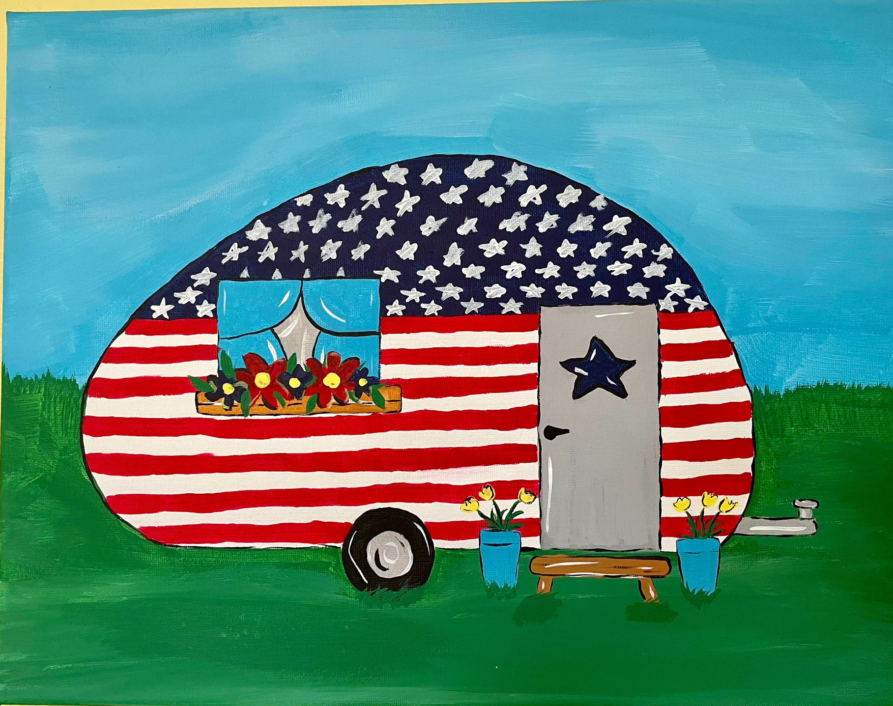
7-10pm DJ at the Pavilion

SUNDAY
10:30am Barrel Train behind the store
12pm-2pm Pizza, wings, ice cream at the Snack Bar
2:30pm Tie Dye T-shirts at Pavilion $8
3-8pm Bad Axe Escape Room near the Pavilion $20/person, groups 6-8 people, sign up ahead of time in the store. Pay vendors directly.
4-5pm Bingo at Pavilion $1
5pm-9pm Pizza, wings, ice cream at the Snack Bar
6:30pm Hula Hoop Rock, paper, scissors, hop
6:45pm 50/50 Drawing Winner, 50 to winner/50 to winners choice of charity
9pm/dusk Movie near the Pavilion. Popcorn $1

MONDAY
9am-12pm $ Phatrods Foodlove Breakfast/lunch Food Truck near the pavilion

Memorial Day
Thank you for camping at the Emmett KOA.

**Weather permitting; activities may be held under the pavilion due to rain.

