- ALL REGISTERED CAMPERS AND VISITORS MUST HAVE A WRISTBAND SHOWING REGISTRATION.
- Visitors are welcome for an additional $6 a person and their car will remain in visitors parking with a carpass.
- Check out is Noon; late check out is available for an additional $15 extending check out time to 5pm for all campsites excluding accommodations, if the site is available.
- NO OUTSIDE FIREWOOD.
- PETS ARE WELCOME IF THEY ARE CONTROLLED AND CLEANED UP AFTER.
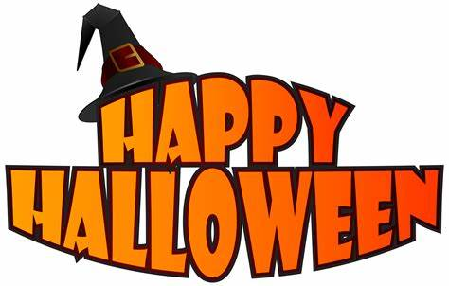
HALLOWEEN WEEKEND EVENTS
WIFI – Emmett KOA Guest – Password: happycamper
Store Hours 9am-9pm
Wood Deliveries, Jumping Pillow, Bike, Putt Putt 9am-7pm
Bathhouse Daily Cleaning 9am, 2pm and 7pm
Swimming and Catch and Release Fishing Dawn- Dusk
**Reserve your current campsite for this weekend in 2022 by Sunday at Noon. **
FRIDAY
Don’t forget to vote on your favorite decorated campsite.
5pm-9pm Pizza, Wings, Ice Cream at Snack Bar
8pm/dusk Movie under the stars near the Pavilion.
SATURDAY
Order breakfast pizza for Sunday morning delivery
10:30am Barrel Train behind the Store. Weather Permitting
11:30-12:30pm Pumpkin Painting $5/pumpkin at the Pavilion
12pm-2pm Pizza, wings, ice cream at the Snack Bar
2pm Wine Tasting at the pavilion $5/4 wines
3-8pm Bad Axe Escape Room near the Office. $20/person, Groups of 6-8, Sign up before 3pm in the Office or after 3pm at the Escape Room.
4pm Costume Contest near the Pavilion
Following the Costume contest will be trick or treating. We ask all traffic holds for the hour of trick or treating. We will not be allowing any incoming traffic.
4pm-8pm Pizza, wings, ice cream at the Snack Bar, last pizza order at 7:30pm
7pm-10pm DJ at the Pavilion
8pm Hayride begins to the Haunted Forest meet behind the Store or you may walk to the forest.
8pm Last Chance to vote for your favorite decorated site.
SUNDAY
9am-10am Breakfast Pizza Delivery, order in advance while supplies last
10am Announce Site Decorating Winner at the Pavilion. Must be present to win.

**Weather permitting; activities may be held under the pavilion due to rain.

