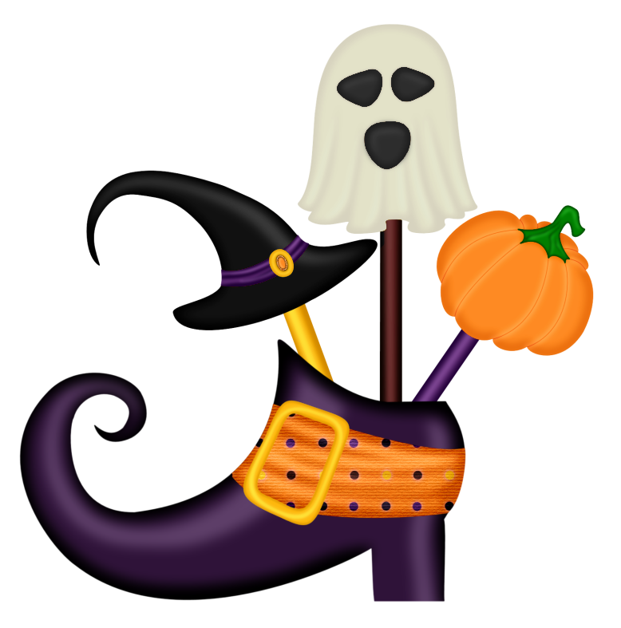
**NEW THIS WEEKEND WITH RESERVATIONS: Saturday Oct 14th at 8AM sites will open for reservations for Halloween 4 2018 TWO (sites) per person maximum (October 12-14 2018) **
Numbers will be given approximately at 7am by Chris. Must be present when # is called.**
Halloween 4
At Emmett KOA
10/13-10/15
Friday- 9:00am-DUSK $Jumping Pillow
5:00-9:00 Flipper Snack Bar at the Pavilion (last order 9:00pm)
8:15pm Halloween movie under the Stars/ $1 Popcorn

Saturday 9:00am-DUSK $Jumping Pillow
10:00-10:30 Barrel Train ride meet in front of the store (must have VIP wristband for entry)
11:00am-11:45am Halloween Magic Show at the Pavilion
12:00-12:45 Pumpkin Painting at the Pavilion $5 per pumpkin (last call 12:20 for pumpkins)
1:00-3:00 Flipper Snack Bar at the Pavilion
1:00-1:15 Marshmallow Zombie Fight at the Gaga Pit
1:30-2:30 $1 Halloween Bingo at the Pavilion
3:30pm Costume Judging near playground for all ages (must have VIP wristband for entry)
Following Costume Contest for 1 hr Trick or Treating Site to Site
NO CARS ARE TO MOVE DURING TRICK OR TREATING!

5:00-7:00 Flipper Snack Bar at the Pavilion (last order 6:45)
7:00pm-10:00pm Ghost & Goblins Dance Party at the Pavilion
7:30pm-? Wagon Ride to Haunted Forest Meet in front of the Store (must have VIP wristband for entry) Weather Permitting
**Saturday October 2nd10AM sites will open for reservations for Halloween 2 2016 (September 30-October 2)

Sunday- 9:00am-10:30am $ Breakfast at the Pavilion
Adults $7/ Children 10-under $4
9:00am-12:00pm $Jumping Pillow
10:30am Prompt Announce Site
Decorating Winners at the Pavilion- Must be present to win!
Flipper Snack Bar
Friday 5pm-9pm
(last pizza/wing order 8:45pm)
Saturday 1pm-3pm & 5pm-7pm
(last pizza/wings order 6:45pm)
THIS WEEKEND BUY 1 ICE CREAM GET 1 FREE!!

