- ALL REGISTERED CAMPERS AND VISITORS MUST HAVE A WRISTBAND SHOWING REGISTRATION.
- Visitors are welcome for an additional $6 a person and their car will remain in visitors parking with a carpass.
- Check out is Noon; late check out is available for an additional $15 extending check out time to 5pm for all campsites excluding accommodations, if the site is available.
- NO OUTSIDE FIREWOOD.
- PETS ARE WELCOME IF THEY ARE CONTROLLED AND CLEANED UP AFTER.

EMMETT KOA
MOTHERS DAY WEEKEND EVENTS
WIFI – Emmett KOA Guest – Password: happycamper
Store Hours 9am-9pm
Wood Deliveries, Jumping Pillow, Bike, Putt Putt 9am-8:45pm
Bathhouse Daily Cleaning 9am, 2pm and 7pm
Swimming Pond and Catch and Release Fishing Dawn- Dusk

**Reserve your current campsite for this weekend in 2022 by Sunday at Noon. **

FRIDAY
5pm-9pm Pizza, Wings, Ice Cream at Snack Bar
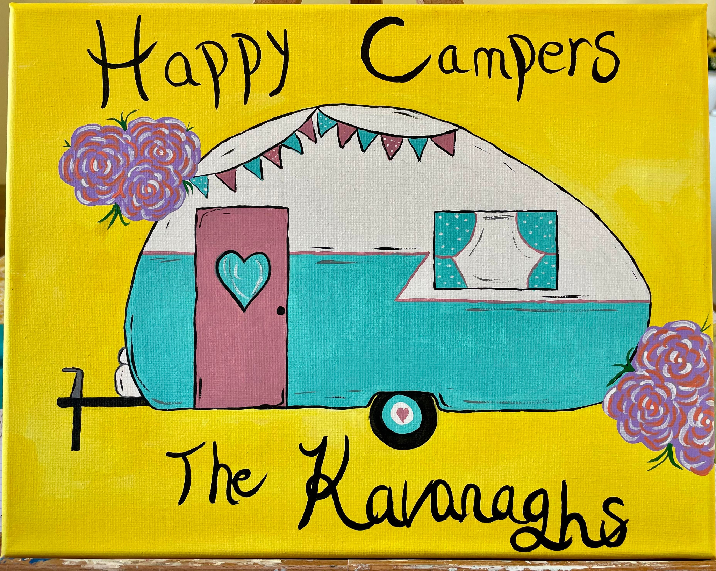
9pm/dusk Movie under the Stars near the pavilion, Popcorn $1
SATURDAY
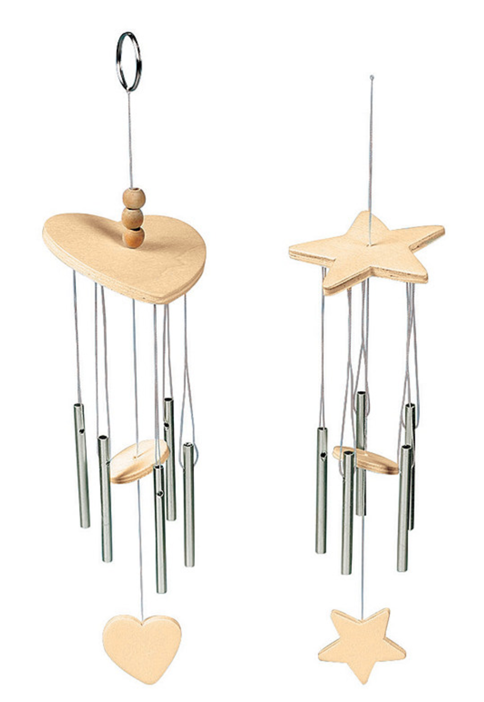
10:30am Barrel Train behind the office
11:30am Arts & Crafts at the Pavilion
12pm-2pm Pizza, wings, ice cream at the Snack Bar
2:30pm Parents versus kids obstacle course
4pm-5pm Bingo at Pavilion $1
5pm-9pm Pizza, wings, ice cream at the Snack Bar
6pm Wine tasting $5 at the pavilion
6pm-9pm Guided Canvas Painting $15
6pm Hula Hoop games near the pavilion
7pm Barrel Train behind the office
SUNDAY
9am-12pm $$ Tracy B’s Breakfast/lunch Food Truck near the Pavilion
12pm-2pm Pizza, wings, ice cream order in the Store
Store Hours 9am-5pm
**Weather permitting; activities may be held under the pavilion due to rain.

