- ALL REGISTERED CAMPERS AND VISITORS MUST HAVE A WRISTBAND SHOWING REGISTRATION.
- Visitors are welcome for an additional $6 a person and their car will remain in visitors parking with a carpass.
- Check out is Noon; late check out is available for an additional $15 extending check out time to 5pm for all campsites excluding accommodations, if the site is available.
- NO OUTSIDE FIREWOOD.
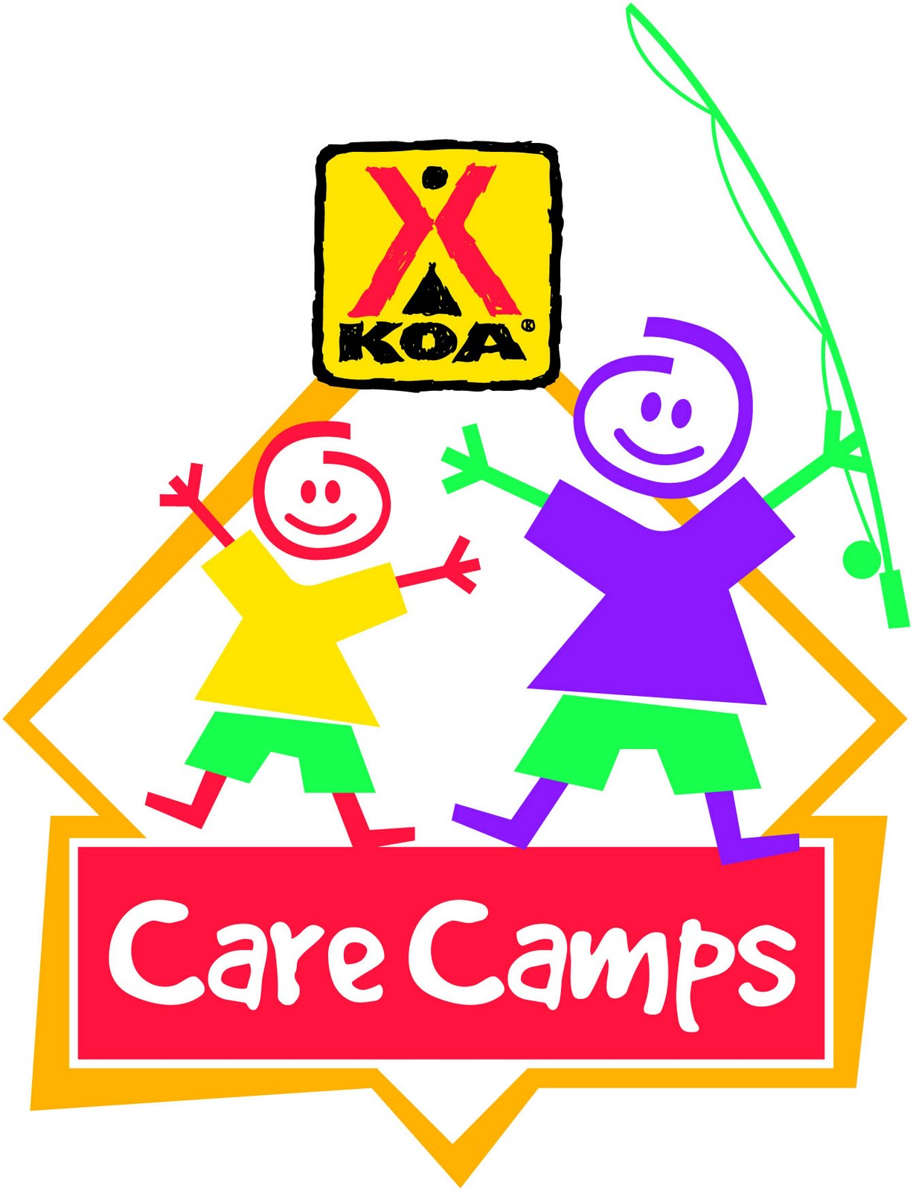
- PETS ARE WELCOME IF THEY ARE CONTROLLED AND CLEANED UP AFTER.

EMMETT KOA
CARE CAMP WEEKEND EVENTS
WIFI – Emmett KOA Guest – Password: happycamper

Store Hours 9am-9pm
Wood Deliveries, Jumping Pillow, Bike, Putt Putt 9am-8:45pm
Bathhouse Daily Cleaning 9am, 2pm and 7pm
Swimming Pond and Catch and Release Fishing Dawn- Dusk

**Reserve your current campsite for this weekend in 2022 by Sunday at Noon. **

FRIDAY
5pm-9pm Pizza, Wings, Ice Cream at Snack Bar
9pm/Dusk Movie under the stars near the pavilion, Popcorn $1 - All funds go to care camp

SATURDAY
9am-7:30pm GET YOUR 50/50 TICKETS $1- 1, $10 - 5 in the office
10:30am Barrel Train behind the office
12:30pm Ice Cream Social $5 (vanilla ice cream with selection of toppings) - All funds go to care camp
12pm-2pm Pizza, wings, ice cream at the Snack Bar
2:30pm Cornhole Tournament $10/team - All funds go to care camp. Sign up in the store by 1pm
4pm Hula Hoop Hop, Rock, Paper, Scissors near the pavilion
5pm-9pm Pizza, wings, ice cream at the Snack Bar
6pm Barrel Train behind the office
7pm-8pm Bingo at Pavilion $1 - All funds go to care camp
8pm 50/50 Winner at the pavilion
SUNDAY
12pm-2pm Pizza, wings, ice cream order in the Store
Store Hours 9am-5pm
**Weather permitting; activities may be held under the pavilion due to rain.

