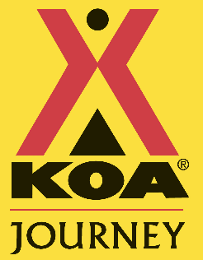

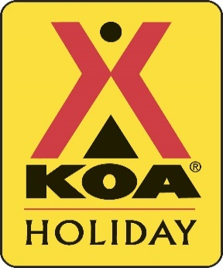


fgdf [Grab your reader’s attention with a great quote from the document or use this space to emphasize a key point. To place this text box anywhere on the page, just drag it.]
Hours of Operation:
Office
Clubhouse
8:30 am–9 pm




*Decorate your RV, trailer, or tent for Halloween for a chance to win grand prizes up to $300!!*

Every Friday – Costume Contest – including pets!
With spooky refreshments @ 6pm-7pm
Deck yourself or your pets out in your best costumes! Winner will receive a prize. All while enjoying delicious hotdogs with all the trimmings, sipping on a yummy Halloween-themed beverage, and socializing with your besties and bro-buds! Please enjoy trick-or-treating around our campground. Also check out our pumpkin patch and haunted hay rides today!

Every Saturday – Pumpkin decorating and scary movie @ sunset
Bring a blanket or chair and make yourself cozy - it’s scary movie time! Munch out on popcorn, it’s Saturday night fun for the entire family! If you’re feeling chilly, tell ghost stories around a cozy campfire! Pumpkin decorating for $10 – we provide the paints and you get to keep your beautiful pumpkin until Halloween!

Every Sunday – Pancake Breakfast @ 9am-10am
Winner for the site decorating contest will be announced!
Short stack, coffee, and juice, what a great way to end your weekend of spooky fun - courtesy for our KOA guests!

Complementary coffee every day until 11am!
BRICK OVEN PIZZA $13.99 - Pepperoni, Cheese, & Gluten-Free Veggie
Call to order 509-925-9319

Celebrate the FOUR WEEKENDS OF HALLOWEEN with us in October 2025!

Store Hours
Sun-Thurs 9AM-5PM
Fri-Sat 8AM-7PM

Meet the Team!
Front Desk – Angy, Athena, and Cynthia

Housekeeping – Cynthia, Tad, Kayla, Theo, Makayla, and Suzanne

Maintenance – Craig, Rob, Carter, and Steve

First Friday Art Walk: Enjoy showcases of art in galleries and non-traditional settings. This event is to honor local artists. Friday the 3rd from 5PM-7PM in downtown Ellensburg.
Ellensburg Farmers Market: Saturdays from 9AM-1PM on 4th Street.
Feelin’ Crafty in Ellensburg: Tuesday, October 28 from 4:30pm-6pm in the KCRCO office. Free for all to come and participate in arts and crafts!
Irene Rinehart Riverfront Trail: Pack up the car and get ready to swim, picnic, tan, walk, run, boat, or bike at this quaint Ellensburg trail.
Umtanum Creek Falls: 1.9 mile out-and-back trail to a luscious waterfall paradise!

Ellensburg KOA Journey

