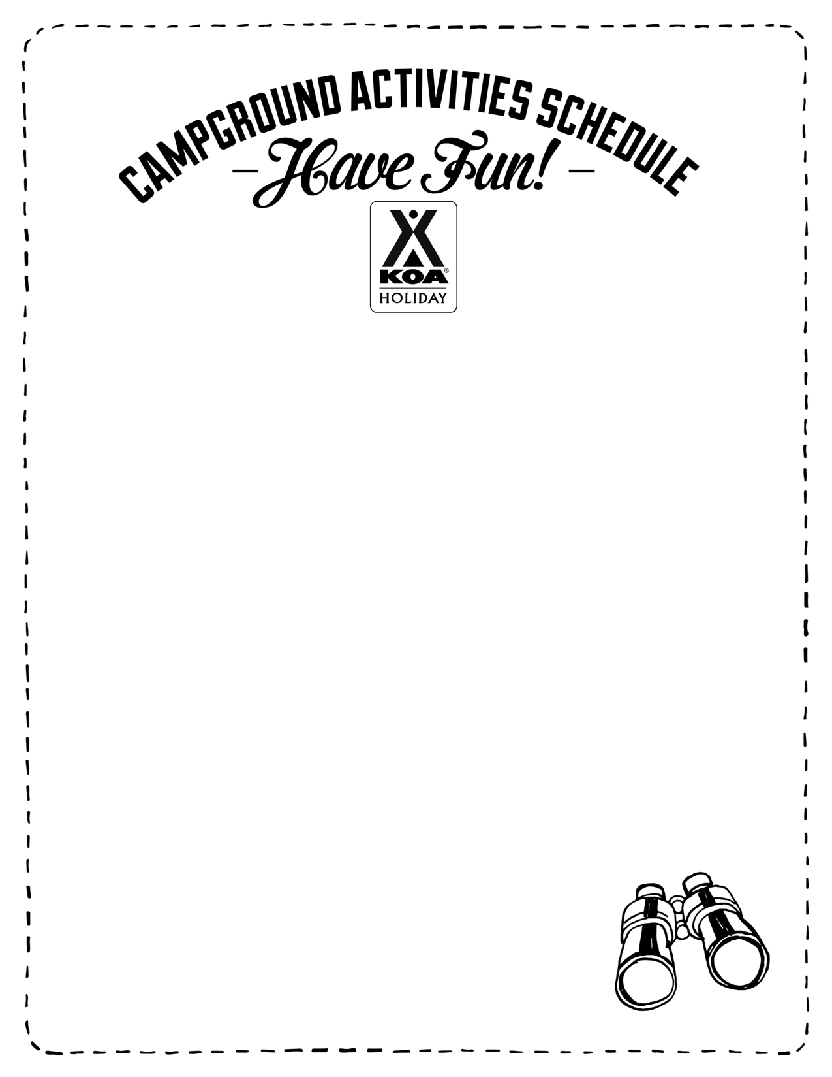
2023 THEMED WEEKENDS
We offer planned activities every weekend from May – October. Listed below are weekends that have a specific theme that will go along with the planned activities.

May 5th & 6th Planned Activities!
May 12th & 13th KOA Care Camps!
May 19th & 20th Planned Activities!
May 26th-28th Heroes Weekend!
June 2nd & 3rd Planned Activities!
June 9th & 10th Schools Out Party!
June 16th & 17th Dad Games 2023!
June 23rd & 24th Planned Activities!
June 30th–July 2nd Party In The USA!
July 7th & 8th Planned Activities!
July 14th & 15th Police vs. Fire!
July 21st & 22nd Planned Activities!
July 28th & 29th Planned Activities!
August 4th & 5th Farmer’s Weekend!
August 11th & 12th Planned Activities!
August 18th & 19th S’more Love!
August 25th & 26th Planned Activities!
September 1st - 3rd Wet and Wild!
September 8th & 9th Planned Activities!
September 15th & 16th Planned Activities!
September 22nd & 23rdPlanned Activities!
September 29th & 30th Halloween Bash!
October 6th & 7th Halloween Bash!
October 13th & 14th Halloween Bash!

*Note: weekends with “planned activities” will have scheduled activities without a theme associated with them. We will post an activity flyer each week with the activities planned for that weekend. *

