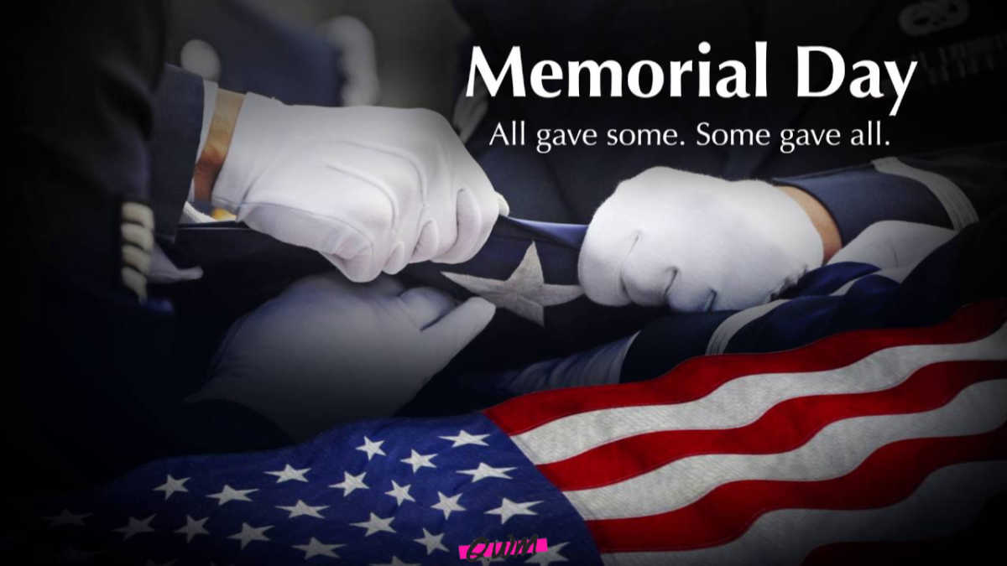
Memorial Weekend Activities
Friday
50/50 Care Camp Raffle Tickets on Sale for $1 a ticket or $4 for 5 tickets or $8 for 10 tickets
Friday Night Done Rite Pizza Special - Pizza, Wings, and Soda one LOW price 6pm-7pm
Movie Madness at the Pool at 8pm at the POOL
Saturday
50/50 Care Camp Raffle Tickets on Sale for $1 a ticket or $4 for 5 tickets or $8 for 10 tickets until 6PM
Positive Pancakes for FREE 9am-10am at the OFFICE
Artsy Fartsy Craft time 10:30am-11:30am at the PAVILION
High Five Tie Dye Tyme 11:30am-12:30pm at the PAVILION
Please purchase tie dye items in the office prior to event
Mountain Top Barrel Train Rides 1:30pm at the PAVILION
Please purchase tickets in the office prior to event
Care Camps Ice Cream Social 2pm-3pm at the OFFICE
Water Wars Parents VS Kids 3pm-4pm at the PLAYGROUND
FYI YOU WILL GET WET- Winner gets PIE!
Saturday Night Riot Food Special KIDS EAT FREE with adult entrée 5pm-6pm
50/50 Care Camp Raffle Tickets on Sale for $1 a ticket or $4 for 5 tickets or $8 for 10 tickets ends at 6pm
Block Party 7pm-9pm at the PAVILION! Drinks, Snacks, Games, Prizes, and more!!!
Sunday
Breakin the Bank Breakfast 2 for $5 8am-10am
High Five Tie Dye Tyme 11:30am-12:30pm at the PAVILION
Please purchase tie dye items in the office prior to event
Mountain Top Barrel Train Rides 3pm at the PAVILION
Please purchase tickets in the office prior to event

