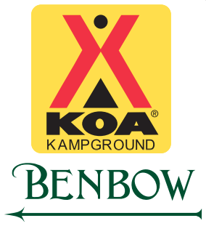
Summer Fun 2020

Activity schedule Memorial Day Week End through Labor Day Week End
Pool & Hot Tub Open Daily from 9:30 am to 9:30 pm
Splash Park Open Daily from 1 pm to 5 pm
EXCEPTION – Memorial Day & 4th of July have added activities. Summer Arts week end has NO activities.
 | Time | Activity | Location
Friday
 | 10-11 am | Barrel Train Rides | Friendship Hall
 | 7-8 pm | Foot Golf Short Game | Hole 1 of Golf Course
 | 8:30 pm | Campfire with Marshmallows & Stories | Community Fire Pit
Saturday
 | 10-11 am | Barrel Train Rides | Friendship Hall
 | 11am – 12 pm | Arts & Crafts | Friendship Hall
 | 5-6 pm | Fun & Games | Splash Park
 | 9 pm | Outdoor Movie | Splash Park
Sunday
 | 10-11 am | Barrel Train Rides | Friendship Hall
 | 7–9 pm | Bingo | Village Hall
Monday
 | 10-11 am | Barrel Train Rides | Friendship Hall
Tuesday
 | 10-11 am | Barrel Train Rides | Friendship Hall
 | 9 pm | Outdoor Movie | Splash Park
Wednesday
 | 10-11 am | Barrel Train Rides | Friendship Hall
 | 9 pm | Outdoor Movie | Splash Park
Thursday
 | 10-11 am | Barrel Train Rides | Friendship Hall
 | 5-6 pm | Fun & Games | Splash Park

