December Greetings from Andover/Pymatuning Lake KOA!
While the campground may be in hibernation for guests, our winter crew is certainly hard at work making your next stay with us even more memorable.
We’ve got several projects up our sleeves, but here’s what we’ve been up to this November:
Replacing several old hose bibbs with
new ones:
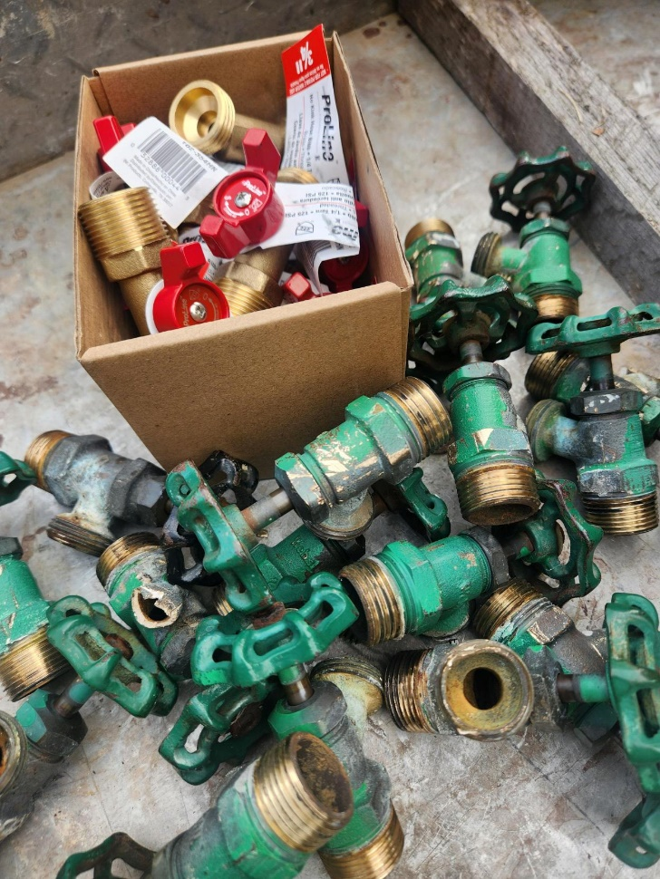
Remodeling the old park model sites into premium full hook-up camping sites:
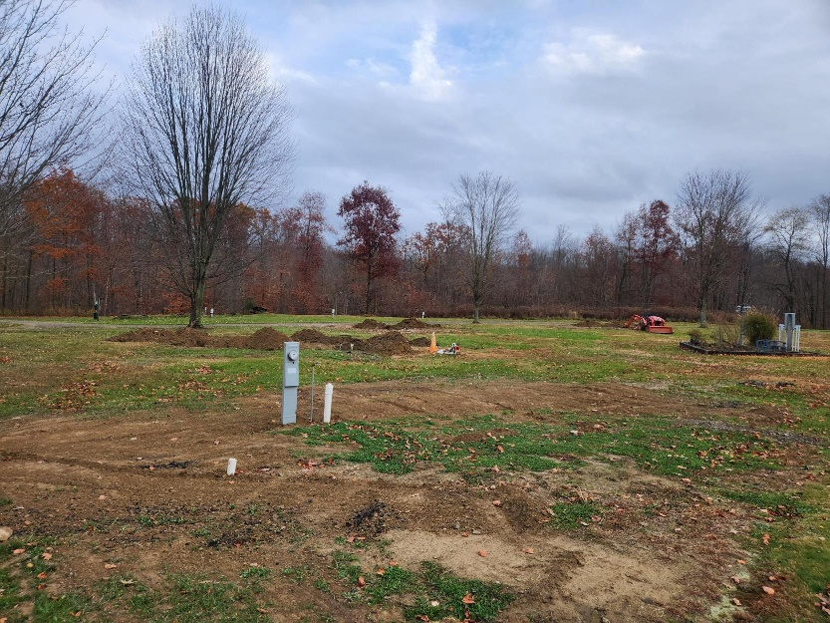
Updating the cabin landscaping (flowers to come this spring!):
Old
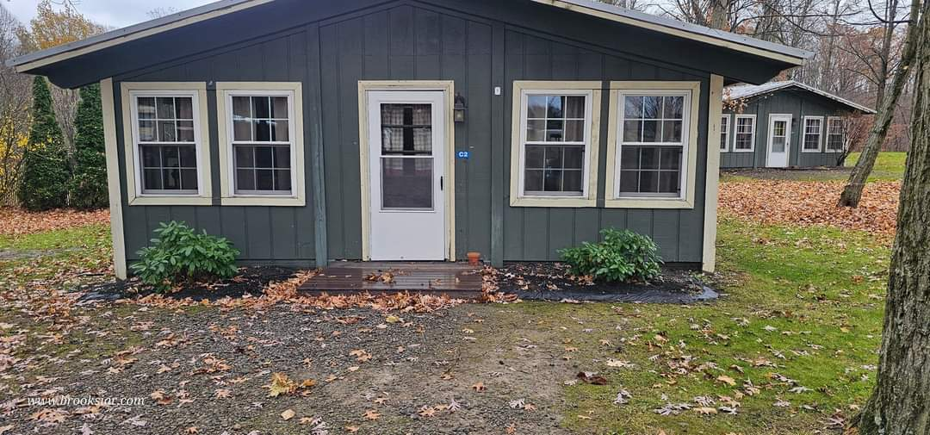
And new
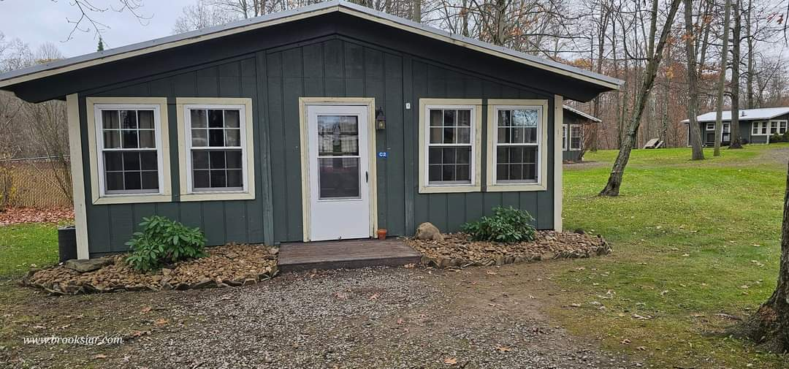
And of course, taking time to goof off and learn new skills while promoting the campground:
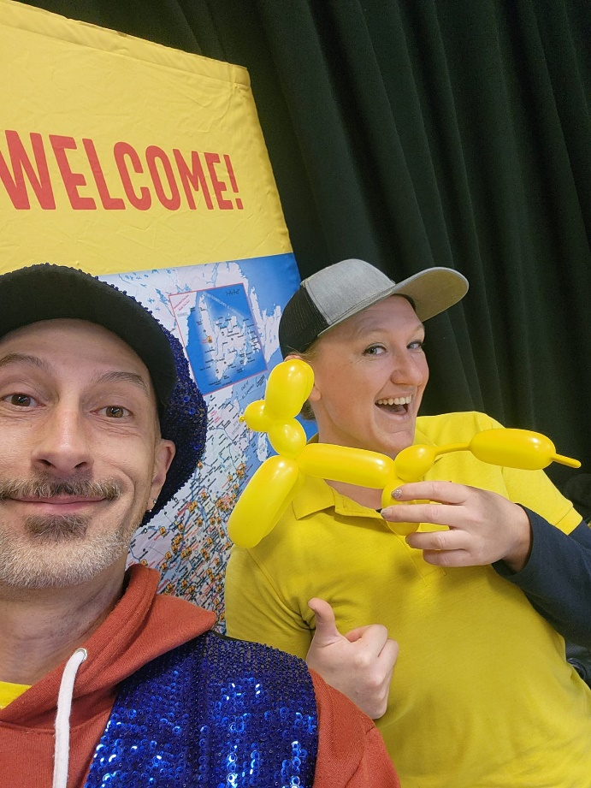

But most importantly, the winter crew want to say we’re most thankful for you and we appreciate your patronage! We can’t wait to see you this spring and show you all the awesome upgrades that are waiting for you!
