Acton/ Los Angeles North KOA Holiday | 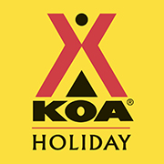
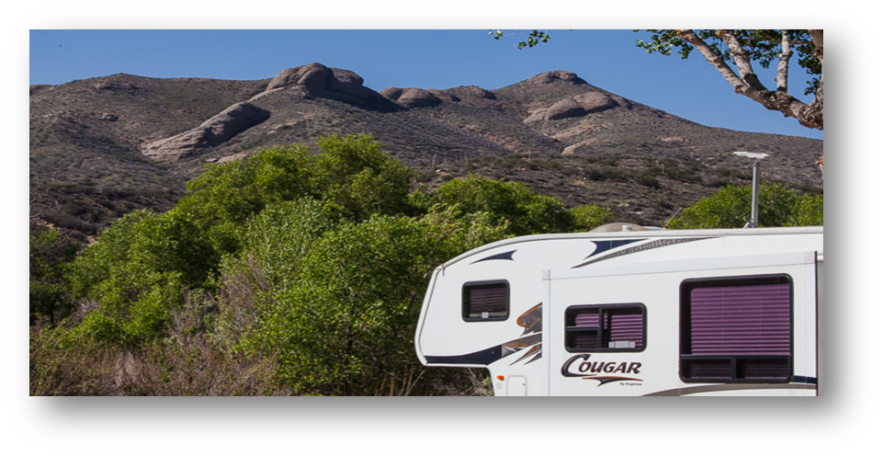  Pricing Information  $850 30-amp Regular RV Site  $880 30/50-amp Regular RV Site  $850 to $880 30-amp Wide RV Site  $880 to $920 30/50-amp Wide RV Site  $890 to $920 30/50-amp Deluxe RV Site  - All Monthly Sites are Full Hook-up Back-In Sites  - 390 Kilowatt included – 0.35¢ per Kilowatt exceeded  - Per L.A. County regulations, guest cannot exceed 2 months in the campground (must check out of the campground for 24 hours and can check back in for another 2 months)  More about our campground: Our campground is surrounded by the beautiful mountains of Soledad Canyon. The Santa Clara River is on our premises which offers a relaxing stream during rain or snow season. If you are looking for a remote location near the city, our KOA will provide you with a serene setting with breath-taking views. Please keep in mind that due to the location of our campground, cellular service is not guaranteed. We offer complimentary Wi-Fi throughout the campground and if you activate Wi-Fi calling you should be able to make and receive phone calls. Also, there is a wild cat sanctuary less than a mile away from our campground and nearby railroad tracks.  It would be a fun experience to hear the wild cats throughout your stay! | 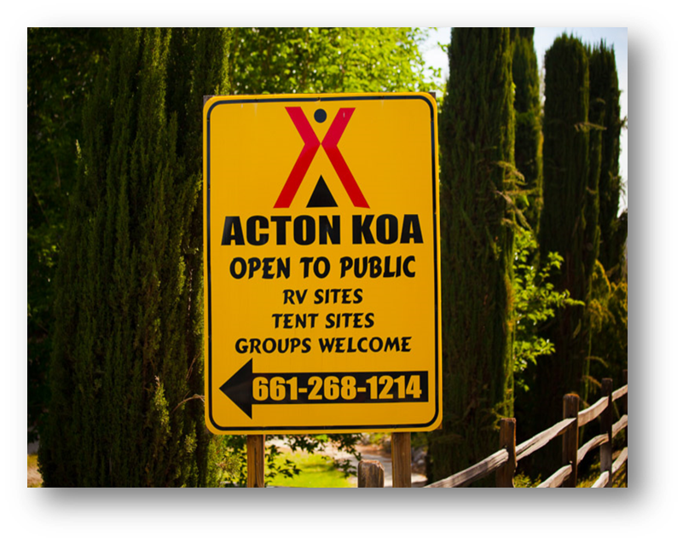  Amenities  Free Wi-Fi  Security Guard On-Site  Laundry Facility  Dog Park  3 Bath Houses with Showers  Hiking Trail On-Site  Lounge w/ cable TV  Movie Rentals  Playgrounds, Volleyball Court, Basketball, Tetherball  Swimming Pool (seasonal)  Hot Tub (Seasonal)  Planned Events (Seasonal)  Planned Activities (Seasonal)  Please contact us with any questions:  661-268-1214

