Golf Cart Rentals

Rental Period | Minimum | Fee
Weekends (Friday-Saturday) | 2 days | $110.00
Weekdays (Sunday-Thursday) | No minimum | $45.00 per day
Holiday Weekends | 3 days | $180.00
Weekly | 7 days | $270.00
Rental Extension Fee | (early pick up/late return with prior approval) | $10.00 per hour
Late returned carts will be charged $25.00 for every hour late. |  | Plus PA tax.
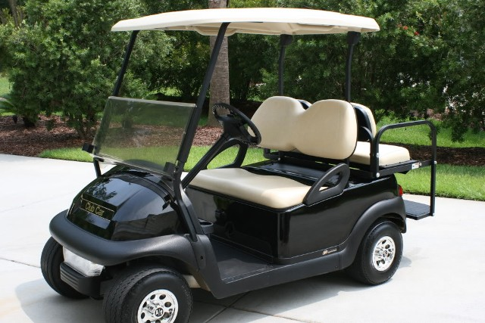

- Golf cart rental times follow check-in and check-out times for rental units and campsites, respectively. Early arrival/late departure may be available for a fee.
- There is a 2 day minimum rental on weekends.
- There is a 3 day minimum rental for Memorial Day, 4th of July and Labor Day weekends.
- Golf carts may be reserved in advance for 2 or more nights (3 nights holiday weekends).
- Full payment required for all advance reservations.
Cancellation Policy:
48 hours’ notice required for cancellation. Fee will be refunded minus a $10.00 administrative fee. Less than 48 hour notice results in no refund of fees. MUST NOTIFY OFFICE BY 4 PM TWO DAYS PRIOR TO CHECK-IN TO QUALIFY FOR ANY REFUND.

Golf Cart Rental Rules

1. Person renting golf cart must be a registered guest and be a minimum of 21 years old.
2. Operator(s) of golf cart must be a registered guest and have in their possession a valid driver’s license. An unauthorized person found driving a golf cart will result in the immediate loss of golf cart and no refund will be given.
3. Lessee shall not assign or sublease the equipment to any other person.
4. Golf carts can carry a maximum of 4 people and all passengers must be seated at all times when the cart is in motion.
5. Golf carts operated after sunset must have lights on.
6. Golf carts cannot be operated during quiet hours (11:00pm to 8:00am)
7. Golf carts must be operated properly. Horseplay, racing, or other misuse of cart will not be tolerated.
8. Carts are to be operated on campground roadways only. No driving through campsites or other restricted areas. Absolutely no golf carts in river or on bike trail.
9. Golf cart must remain in the Uniontown KOA at River’s Edge at all times.
10. Golf carts must be returned at the designated time. Late returned carts will be charged $25.00 for every hour late.
11. Lost keys will result in a $25.00 fee.
12. Please report any malfunctions to Management immediately.
13. Anyone found abusing the rules and regulations of a rental golf cart will forfeit all rental privileges. There will be no refunds made if the cart has to be returned because of lessee misuse.
14. All Golf Cart rentals must be paid in full at the time of booking with a Credit Card or a cash payment will be accepted; however, a Credit Card must be on file with office upon pick up of the cart.
15. Golf cart rental times follow check-in and check-out times for rental units and campsites, respectively. Early arrival/late departure may be available for a fee.
For more information or to reserve a cart call: 724-628-4880 extension “1”.

