Sunday  Dec. 7th | 2pm - 3pm Ice Cream Social $1/Scoop ---on the patio.  Be sure to look closely at the changes in our exercise classes this week  On-going NFL Games and Home Day Sunday---Florizona Grille
Monday  Dec. 8th | 10am Fabric Coloring! $---Grand Canyon Room  Color a Wild West T-shirt, Pillowcase, or Bandana for $1  Monday Night Football and Cajun Monday---Florizona Grille
Tuesday  Dec. 9th | 1pm Water Aerobics---Main Pool  Italian Tuesday---Florizona Grille!
Wednesday  Dec. 10th | 11am Pickleball---Event Center (tent)  Mexican Wednesday---Florizona Grille!
Thursday  Dec. 11th | Steak Thursday---Florizona Grille!
Friday  Dec. 12th | 5pm Movie Night “It’s a Wonderful Life”!--- Grand Canyon Room  7pm Movie Night Continued “Prancer”---Grand Canyon Room  Free Popcorn for both! Candy and drinks will also be for sale! Come join the FUN!  Fish Fry---Florizona Grille  Holiday Nights – Nearly a Million Lights at Tohono Chul Park 5:30 – 8:30pm
Saturday  Dec. 13th | 11am Pickleball--- Event Center (Equipment is also available to check out at the front desk daily)  2pm Beginning Spanish Class!---Sabino Room  Join us for BBQ Chicken or Ribs followed by line dancing at 7:30pm!!---Florizona Grille  Holiday Nights - Nearly a Million Lights at Tohono Chul Park 5:30 - 8:30pm
Florizona Grille is open 7 days a week 8am – 9pm
Breakfast 8 – 11am / Lunch Special 11am – 4pm
Happy Hour is 4 – 6pm daily! / Dinner Special 5 – 9pm
Dinner specials are ALL-U-CAN-EAT with a salad bar.
No salad bar on Friday

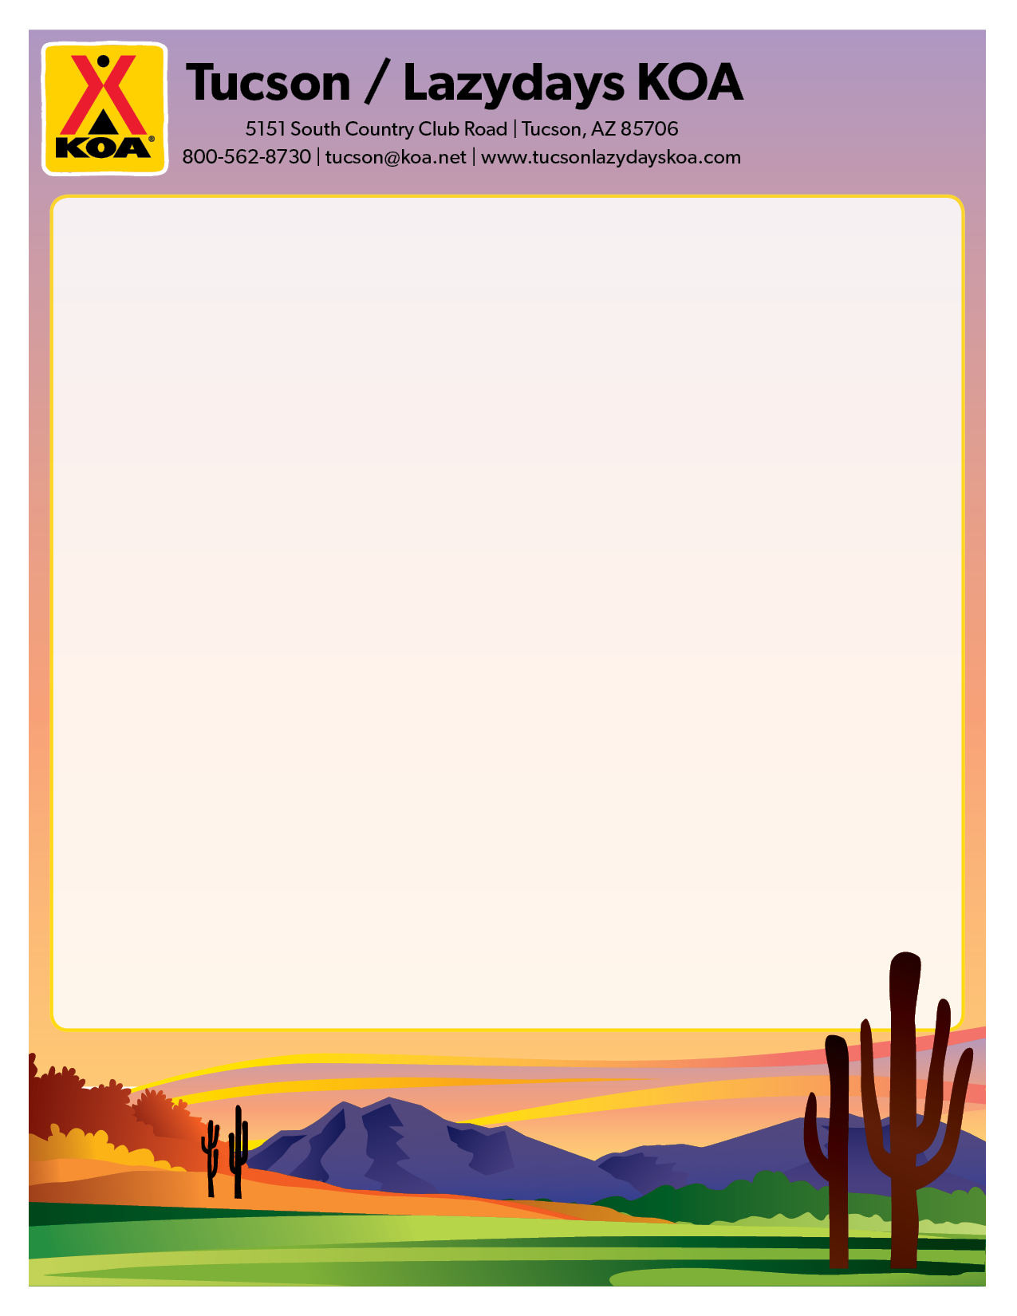

If you would like to see an activity offered or would like to volunteer to put on an activity, please write it down with your contact information. Give it to the front office and they will forward it to Andrea, the activities director.

