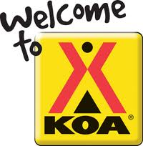
Stockton Delta KOA
Activity Schedule

Friday Aug 23rd
7-8 pm - Ice Cream Social
Join us at Sunset Sweets located across from the KOA Kamp Store
9:00 pm – Join us at the “Under the Stars Theater”
Located behind the Pavilion as we watch “up” On the Big Screen!

Saturday Aug 24th
10am: –SURPRISE ACTIVITY!
Located AT the Pavilion
11 am: – Make your own Sun-Catcher and Funny Face painting!
Located at the Pavilion
1:30 pm – TIE DYE at the Pavilion!!!

Watch on the Big Screen “A Bugs Life” at dusk!

