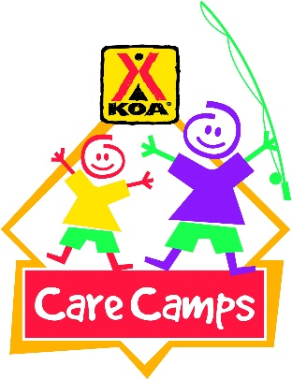
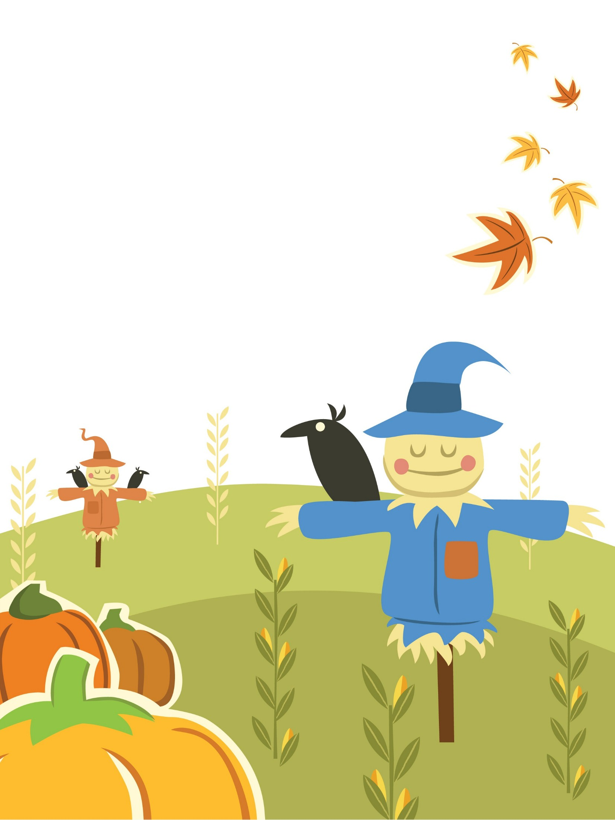
We invite MT. St. Helens KOA 1st Annual
  - Kamp OR Treat

A Spooktacular Event for Families
- Pumpkin Carving Contest- cost of pumpkin is by donation to benefit KOA Care Camps for children with cancer.
- Potluck Halloween Party –Bring your favorite finger food!
- Bingo-50% of proceeds going to benefit KOA Care Camps.
- Costume Parade & Trick Or Treating
- Camper Decoration Contest- Grand Prize Winner
Where: 167 Schaffran Rd, Castle Rock Call for more info: (360)-274-8522
When: Saturday, October 24, 2015
Time: 6pm-8pm

