Stamp Chart  Petting Farm Arts & Crafts Scavenger Hunt  Hay Wagon Rock Wall Petting Farm  Banana Bikes Rocket ship Fun Sno Cones  Miners Camp Banana Bikes Face Painting  Karaoke Hay Wagon Family Movie  After you do an activity, ask the KOA Rec Staff at the station to receive a stamp.  If you get a stamp for all the activities, you get a special surprise Sunday Morning at Petting Farm! | 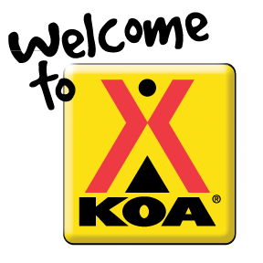  San Francisco North/  Petaluma KOA  20 Rainsville Road  Petaluma, Ca 94952  Call or Visit  (707) 763-1492  PetalumaKOA.com  Follow & Like! | San Francisco Tours  Enjoy a fantastic tour of San Francisco! Our friendly tour guides will take you to the best sites and provide fun and interesting information. Let us show you everybody's favorite city! The tour leaves the campground daily.  New Valley View RV Sites  Come see our brand new RV area! You have been asking for an RV area close to the pool & activities so we spent the winter building a great new RV area for your convenience and enjoyment. The area has a variety of RV sites including 100 foot pull thru sites with large Patios & VIP septic pumping, private Back-in RV sites with VIP septic pumping and water and electric back in sites. These new back in sites are designed for your privacy and relaxation!  How can we improve  your stay?  The Petaluma KOA is always looking for feedback from our campers! Email suggestion on how we can make your stay better at KOARecreation@gmail.com | Monday-Thursday  8-10pm Arcade @Rec Hall  8-8pm Bocce Ball & Horseshoe  9-9:45am Petting Farm  9-9:30 Scavenger Hunt @Petting Farm  9am-10pm HOT Tub & POOL  10-11am Color Time @Store Front  10-11am Face Painting @Store Front  12:15-5pm Bike Rentals @Rec Hall  4:05pm Train Ride @Playground  5-5:45pm Petting Farm  5:15-6:15pm Arts & Crafts @Store Front  6pm Hay WAGON @Playground  6:30-7:30 ROCK Wall @Store Front  7-8pm Ice Cream Social @REC Hall  8:30pm Family Movie @Pool Side  Visit Us Again!  Safari Week: June 19-25  4th of July: June 26-July 4th  Magic Week: July 5-9

