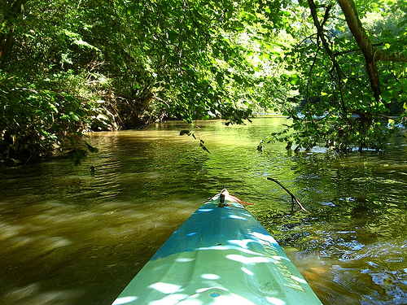  Nov. 11, 2017  8 Am to 12 noon  NAPLES/MARCO ISLAND KOA  KAYAKATHON TO BENEFIT KOA CARE CAMPS FIVE MILE COURSE OR “DO YOUR OWN THING”. PRE-REGISTRATION BY OCTOBER 11, 2017 IS $35.00. LATE REGISTRATION IS $45.00. INCLUDES T-SHIRT AND BOTTLE OF WATER.  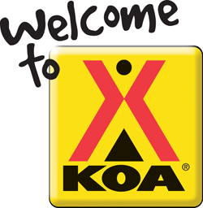 | REGISTER IN OFFICE AND RECEIVE T-SHIRT AND BOTTLE OF WATER  ────  PADDLE TO SEND A KID TO CAMP  ────  $ BBQ LUNCH AVAILABE FROM 12 NOON TO 2 PM  ────  RAFFLES AND VENDOR TABLES  ────  35% OFF YOUR STAY WITH US AT NAPLES KOA  nAPLES/MARCO ISLAND KOA  1700 BAREFOOT WILLIAMS RD. NAPLES,  FL. 34113  239-774-5455  NAPLESKOA.COM  Dates and Times

