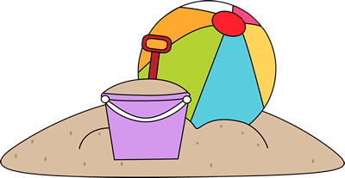
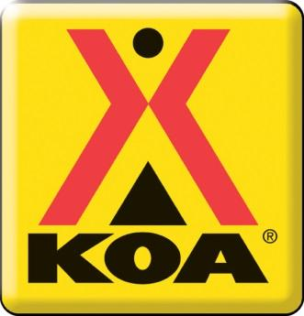
Activity Schedule
August 11th – August 14th
Thursday,  August 11th | Friday,  August 12th | Saturday,  August 13th | Sunday,  August 14th
11:30 AM  Finger Painting  Come to Buoys Grill to make a beautiful piece of art!  1:30 PM  Water Balloon Baseball  Batter up! Meet at Forest Park to play this fun game!  7:00-10:30 PM  Karaoke  Let loose at the Stage with some rockin’ tunes. | 1:30 PM  Dodgeball  Come to Forest Park and show us what ya got!  3:30 PM  Water Balloon Fight  Get involved with this epic battle at Forest Park.  8:00 PM  Movie Night  Join us at the Pool to watch Dr. Suess’ The Lorax. | 11:30 AM & 1:30 PM  Pirate Ship Ride  All aboard the pirate ship for a fun ride around the campground!! Rides leave from the front of the Store.  3:00 PM  Tie Dye  Get the feel of the 60s at Buoy’s Grill with a tie dye t-shirt. All shirts are $5, and all proceeds go to Kare Kamps.  7:00-10:30 PM  Karaoke  Come get crazy at the Stage. You won’t regret it! | 1:30 PM  Capture the Flag  Meet at Forest Park ready to outwit your opponent!  8:30 PM  Flashlight Candy Hunt  Meet at Buoys Grill to grab some candy! We will provide bags, but bring your own flashlight!

** In the event of rain, alternate activities will be offered in the A-Frame. **

