Monday,  June 27th | Tuesday,  June 28th | Wednesday,  June 29th | Thursday,  June 30th | Friday,  July 1st | Saturday,  July 2nd | Sunday,  July 3rd
11:00 AM  Finger Painting  Not afraid to get a lil’ messy? Come to Buoy’s Grill!  1:00 PM  Wiffle Ball  Meet at Forest Park to play this classic game.  3:00 PM  Parachute Games  Come to Forest Park! It will be loads of fun!!  6:00 PM  Back Yard Games  Come to Buoy’s Grill and play Corn Hole, Kan Jam, and Ladder Ball. Bring money for a sweet treat! | 10:30 AM  Bounce Pillow Games  Think you can jump so high you can touch the stars? Come show us at the Bounce Pillow!  2:00 PM  Billy Ball  Come to Forest Park to play this exciting game!  9:00 PM  Flashlight Candy Hunt  Come to Buoy’s Grill and bring a flashlight! We provide bags. | 10:30 AM  Coloring  Get to know the Summershiners a little better at Buoy’s Grill.  2:00 PM  Crazy Soccer  Join us at Forest Park for soccer with a fun twist!  3:30 PM  Duck Duck Splash  Come to Forest Park to play Duck Duck Goose! Be prepared to get wet! | 11:00 AM  Buoy Bingo  Come to Buoy’s Grill ready to play some  B-I-N-G-O!!  1:30 PM  Hula Hoop Tag  Play this fun game at Forest Park!  3:30 PM  Prison Ball  Come break out of jail at Forest Park! | 11:00 AM  4th of July Craft  Come to Buoy’s Grill and get a lil’ crafty with the Summershiners!  1:30 PM  Water Wars  Come to Forest Park prepared to get soaked!  3:00 PM  Jedi Dodgeball  Think the Force is strong with you? Come find out at Forest Park!  8:30 PM  Movie Night  We will be showing Jaws at the Pool. | 11:00 AM  Bandana Bracelets  Meet at Buoy’s Grill to make a red white and blue bracelet.  1:30 PM  Tie Dye  Come dye a KOA shirt. Meet by Buoy’s Grill. Shirts are $5 and proceeds go to Kare Kamps.  2:00 PM  Pool Volleyball  Meet in the Pool! Yayyyyy!!  7:00-10:30 PM  Karaoke  Come to the Stage ready to sing and dance! | 10:30 AM  Chapel  Join us for a time of fellowship and learning at the Stage.  1:00 PM  Manicures  We will have 4th of July colors! Meet by Buoy’s Grill.  3:00 PM  Face Painting  Meet at Buoy’s Grill!  7:30-11:00 PM  The Shelley Sasser Band  Come to the Stage and listen to live pop music
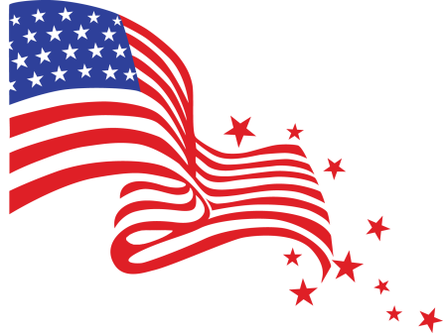
Activity Schedule
June 27th – July 3rd

